
THE BROADCASTER
R A D I O T A L K I N G B O O K S E R V I C E

APRIL 201 9 NEWS L ET T ER │ 201 8 ANNUAL REPORT

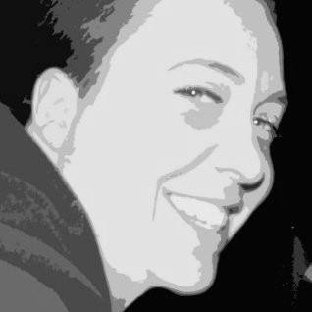BREAKING NEWS!

VIC WAGNER VOLUNTEER COORDINATOR

JOIN OUR TEAM OF AMAZING VOLUNTEERS AND BRING THE PRINTED WORD TO LIFE FOR OUR LISTENERS! VISIT OUR WEBSITE, RTBS.ORG, TO FILL OUT A VOLUNTEER APPLICATION OR CALL VIC TODAY AT (402) 572-3003!
R T B S W E L C O M E S N E W
V O L U N T E E R C O O R D I N A T O R !

Victoria R. ‘Vic’ Wagner is the newest addition to the RTBS staff. Vic has been working with volunteers and nonprofits around the Omaha metro for a number of years. A 2004 graduate of Creighton University, Vic’s first nonprofit gig was with Nebraska AIDS Project where she kicked off her career of service.

When not at the RTBS studios, Vic is spending time at home with her family and their menagerie of pets. Vic’s house is home to chickens, ducks, three aquariums, dogs, cats, and even teenagers! She and her wife, Melissa, can often be found camping with their sons, Thomas and Lincoln. Both boys are very active with Boy Scouts and the family loves the great outdoors and conservation efforts.

Vic is an avid fisherman, crafter, and volunteer with Orchard Hill Neighborhood Association as well as Film Streams to name just a couple of the Omaha area groups and nonprofits she supports. Vic has enjoyed her first few months with RTBS. “It’s a true joy to be among so many other bibliophiles; I love that everyone on staff, especially our volunteers, love books and sharing the written word as much as I do. I am so happy to have found a place on the RTBS team.”

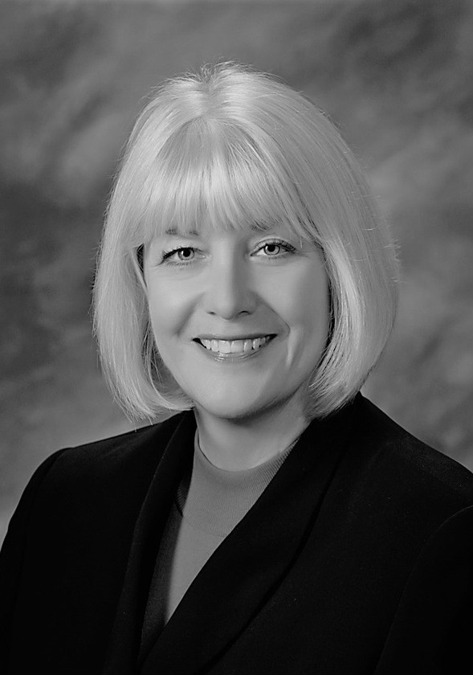

JANE NIELSEN EXECUTIVE DIRECTOR


RALPH MOROCCO BOARD CHAIR

DIRECTOR'S CORNER

Greetings! Radio Talking Book Service will be celebrating 45 years of service to our listeners on September 3rd – 45 years of bringing the printed word to life! RTBS has come this far because of the leadership of individuals serving on the Board of Directors, talented staff, and most importantly, our dedicated volunteers. I recently had a conversation with Sybil Mahan, who was the first Volunteer Coordinator at RTBS. In 1974, the studios and office were at Tech High School and RTBS shared a room with KIOS — all the desks were in a row with studios on one end. Today, as in the beginning, our Omaha broadcast signal is donated to us by KIOS. A partnership with NET ensures access for our listeners across the state.

Some of the early volunteer readers were a gentleman that started KVNO, a UNO professor, and folks from Mutual of Omaha. The Jewish Women’s Association picked reading for RTBS as a volunteer project one year. The advances in technology allow us to reach more and more listeners across Nebraska and SW Iowa but the diverse voices of our volunteers continue to be the heart and soul of this radio station. Stay tuned for details of the RTBS 45th Birthday festivities!
A NOTE FROM THE CHAIRMAN
Back in the era of only three television channels, when our telephones were connected together by the Bell Telephone System’s wires, before the internet had linked more than a few Department of Defense labs, and while computers were the size of several large refrigerators and used only by businesses, Radio Talking Book Service was born to serve those with visual impairments. We delivered news and information from a wide range of printed matter using an over-the-air radio signal.

Over 45 years, RTBS has adapted to bring its product – news, vital information and entertainment – to our listeners with an ever-wider range of tools. Today, we use the tools our listeners want to use. We continue to broadcast an over-the-air signal, but we also offer an internet stream, a dial up service for those who would prefer to use the telephone, podcasts that can be listened to on demand, or downloaded for later listening, and several ways to listen using a smartphone.

RTBS will keep working to deliver our service in new ways that will make information available conveniently, because our mission is to make the inability to read printed matter no longer a disabling condition. Thank you for listening, and for supporting our work as a volunteer and/or donor.

APRIL VOLUNTEER SPOTLIGHT:
VOLUNTEER SPOTLIGHTS
M A R C H 2 0 1 9 : J U D Y P R I C E

F E B R U A R Y 2 0 1 9 : S T E V E S L E E P E R

J A N U A R Y 2 0 1 9 : A N N B O I C E

D E C E M B E R 2 0 1 8 : S U S A N K E L L E Y

N O V E M B E R 2 0 1 8 : L A R R Y T H O R N T O N

O C T O B E R 2 0 1 8 : G E O F F H A M M O N D

Learn more about Rick on our program "Who's Behind That Voice?"!

Tune in at noon on Friday, April 19 or Saturday, April 27 at rtbs.org!
RICK MINER

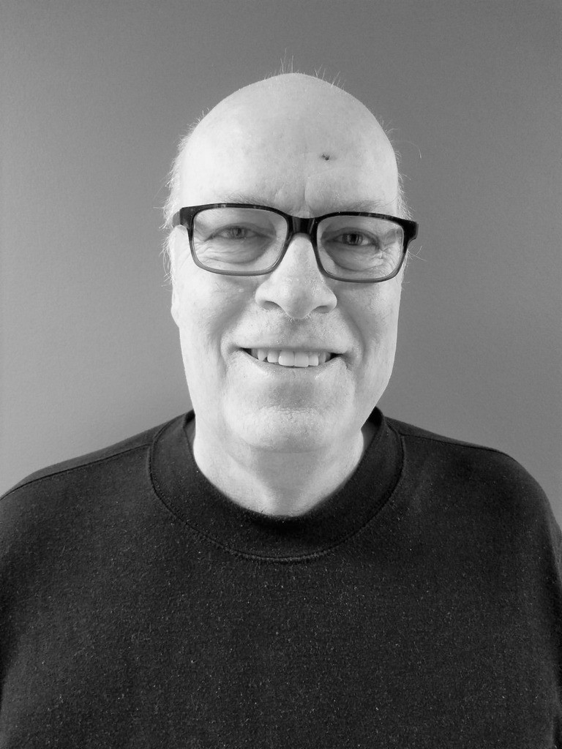
Rick Miner is an avid volunteer and family man. He worked for over 34 years for the Army Corps of Engineers and traveled for projects throughout the States as well as the continent of Africa. Now retired, Rick spends time with Jane, his wife of 46 years, and his son Andrew, a well known local theater actor in Omaha and school teacher in Bennington.
When not watching the Yankees or the Celtics, Rick is volunteering for Radio Talking Book Service, Nebraska Medicine, and Lauritzen Gardens. Rick’s duties at all three are unique and the position with Nebraska Medicine is brand new. Just as Rick assists RTBS listeners with bringing the print word forward, at Nebraska Med he assists oncology patients by teaching them to use tablets to access their medical records, ask questions about their treatment plans, schedule appointments or simply order lunch.

Rick is always willing to help others. It’s no surprise that Rick first learned of RTBS through an internet search.
He was looking for ways to give back and reading for the station seemed like a natural fit as two members of his family experienced Glaucoma and another was blind. Rick loves to read and enjoys sharing that passion with RTBS listeners. He has been a volunteer for over 4 years now! He can be heard every Friday with Ralph Morocco during the live broadcast of the Omaha World Herald and Lincoln Journal Star newspapers.

MARK YOUR CALENDARS!!
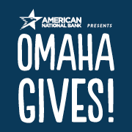
OMAHA GIVES IS MAY 22!!

Radio Talking Book Service is proud to be participating in the 7th annual Omaha Gives!, a 24-hour charitable challenge organized by the Omaha Community Foundation. The online giving holiday will take place May 22 from midnight to midnight. Mark your calendars because we will need your help! Schedule your gifts ahead of time or make donations throughout the day on Wednesday, May 22. Your gift, no matter the size, will be go even further this year with matching funds!! Visit www.omahagives.org to find out how you can help support RTBS on May 22.

RTBS thanks everyone who participated in Omaha Gives! 2018 and helped us EXCEED our goal. We hope this year is even more successful! Visit our website at www.rtbs.org for more information.
Please join RTBS on May 22 to meet our goal of $8,000 for Omaha Gives!.

NEWS FLASH(ES)!!


NEW! Weekly Grocery & Department Store Ads now available on podcast! Visit rtbs.org to listen on demand!

EXTRA! EXTRA! We added the Omaha Star, Hastings Tribune, & Kearney Hub to our local newspaper selections!

SUBSCRIBE! RTBS podcasts now available on iTunes.
Stay tuned for new podcast offerings coming this year!

Many thanks to those who made our 4th Annual Wining in the Dark a success! Keep your eye on our event calendar & join us next year!

Radio Talking Book Network Program Schedule Monday-Friday

12:00 AM Nostalgia Radio 7:00 AM Morning Edition 9:00 AM Morning Break
9:15 AM
MON: Hastings Tribune TUE: Kearney Hub WED-FRI: Daily Extras

9:30 AM
WED: The Omaha Star
THU: Columbus Telegram

FRI: Council Bluffs Nonpareil
10:00 AM LIVE-Omaha World Herald & Lincoln Journal Star

12:00 PM

MON: Department Store Ads TUES: Nebraska Life
WED: Grocery Ads
THU: Blindness & Disability News FRI: Community Conversations
1:00 PM Bookshelf

2:00 PM

MON: What’s Cooking
TUES: Science and Environment WED: Home & Garden
THU: Senior Summary
FRI: Entertainment Update
2:30 PM:
MON: Mystery Theater TUE: Trips & Travel WED: Consumer Info THU: Pet Pause
FRI: Tech It Out!
3:00 PM Sports
3:30 PM Health & Wellness

4:00 PM

M-THU: For Your Information FRI: Eyes on Success
4:30 PM Wall Street Journal

5:00 PM

M: Fremont Tribune
Tu: North Platte Telegraph
W: Grand Island Independent
Th: Scottsbluff Star-Herald
F: Norfolk Daily News
5:45 PM Evening Break
6:00 PM Replay of the Omaha

World-Herald &
Lincoln Journal Star
8:00 PM Replay of 12pm-3pm

11:00 PM Nostalgia Radio

ALL PROGRAM TIMES ARE CENTRAL TIME

SATURDAY
12:00 AM Nostalgia Radio 7:00 AM Weekend Edition 9:00 AM What’s Cooking
9:30 AM Entertainment Update
10:00 AM LIVE-Omaha World- Herald & Lincoln Journal Star
12:00 PM Afternoon Break 12:15 PM Saturday Selections 12:30 PM Tech It Out!
1:00 PM Pet Pause
1:30 PM Mystery Theater 2:00 PM Veterans Hour 3:00 PM Grocery Ads
4:00 PM Blindness & Disability

News
5:00 PM The Catholic Hour
6:00 PM Replay of the Omaha
World-Herald &
Lincoln Journal Star 8:00 PM CBS Mystery Theater 9:00 PM Dusty Attic with Ryan O 10:00 PM Nostalgia Radio

SUNDAY
12:00 AM Nostalgia Radio 7:00 AM Weekend Edition 9:00 AM Guideposts
10:00 AM LIVE-Omaha World- Herald & Lincoln Journal Star
12:00 PM Afternoon Break 12:15 PM Sunday Selections 12:30 PM Good Old Days
1:00 PM Encouragement for the Journey
2:00 PM Nebraska Life 3:00 PM Home & Garden 3:30 PM Senior Summary 4:00 PM Poetry
4:30 PM Eyes On Success
5:00 PM Community

Conversations
6:00 PM Replay of the Omaha
World-Herald &
Lincoln Journal Star 8:00 PM CBS Mystery Theater 9:00 PM Dusty Attic with Ryan O 10:00 PM Nostalgia Radio

Radio Talking Book Service
7101 Newport Avenue, Suite 205 · Omaha, NE 68152
(402) 572-3003 · rtbs.org · info@rtbs.org

DONATIONS: April 2018-March 2019

CORPORATE/FOUNDATIONS
Ethel S. Abbott Foundation Back 2 Health
Bank of the West
JK Barker Foundation
Oliver & Ferrol Barklage Foundation
Marshall & Mary Brondum Special Assistance Foundation Category One Consulting
Dixon Family Foundation
Max & Victoria Dreyfus Foundation Rupert Dunklau Foundation
Ike & Roz Friedman Foundation Hawks Foundation
Gilbert M. & Martha H. Hitchcock Foundation Immanuel Vision Foundation
Iowa West Foundation Kroger Stores
Milton & Corrine Livingston Foundation Lozier Foundation
Midlands Community Foundation Papillion Community Foundation William R. Patrick Foundation
Edward & Lida Robinson Charitable Trust Sherwood Foundation
Manota E. Simon Foundation Cari Sommer Charitable Fund Steinhart Foundation
Robert H. Storz Foundation Wayne State College Webster Family Foundation
ORGANIZATIONS/COMMUNITY GROUPS
Battle Creek Lions Club Clay Center Lions Club Columbus Noon Lions Club Cook Lions Club
Crete Lions Club Genoa Lions Club Gordon Lions Club IAAIS
John C. Fremont Lions Club Lutheran Women of Omaha Millard Lions Club
Millard Noon Lions Club Murdock Lions Club Nebraska Lions Foundation Neligh Lions Club
Omaha Association of the Blind O’Neill Lions Club
Optimist Club of Omaha
Original New Friends Club of Omaha Outlook Nebraska
Papillion Area Lions Club Patient Care Counsel
Presbyterian Women in the Congregation St. James United Methodist Women Tekamah Lions Club
Theos West Omaha Chapter Wallace Lions Club
Wilcox Lioness Club

IN-KIND DONATIONS
Anonymous Bakers (Ames) Blue Barn Theater Charlestons Chick-Fil-A
Columbus Telegram
Council Bluffs Daily Nonpareil Betty Deepe
Fremont Tribune Bob Goding Golden Corral
Grand Island Independent Home Depot
HyVee (Peony Park) Jimmy Johns Debra Kaplan
KIOS-FM
IN-KIND DONATIONS

Rita & John Klingman Adam Kuenning Lincoln Journal Star Ralph Morocco
NET
Jane Nielsen Norfolk Daily News
North Platte Telegraph Nothing Bundt Cakes Orsi's
Ryan Osentowski Sam's Club Target (Sorenson)
WINING IN THE DARK SPONSORS

Anonymous
Security National Bank Bonnie Jerde
Outlook Nebraska Michael Pflueger
Identity Marketing Group Bland Cares Foundation Medicare Insurance Solutions Immanuel Communities
Oh-K Fast Print UNDERWRITING
Blue Cross & Blue Shield of Nebraska
Outlook Nebraska
Pro Insurance Resources SEi Medical Alert WellCare of Nebraska

INDIVIDUALS INDIVIDUALS INDIVIDUALS INDIVIDUALS

Dorothy Abbott Deb Ady
Avis Anderson Jon Anderson Nancy Anderson Anonymous
Kenneth Barjenbruch Laura Beth Barr Dolores Barraclough Bob Bastarache Libby Bates
Michael & Linda Bechtel
Craig Becker Susan Beeghly
Tim & Kathy Bessmer
Mary Bezy
Morey Birenbaum Tom & Patricia Blasing Arlene Blobaum Carolyn Blobaum Gene Blobaum
John & Kathy Blobaum Lois Blobaum
Melodee Bock Patty Bogatz Carole Ann Boice Joni & Bill Bollinger
John & Elaine Boyce Jovita Bramhall
Pat Brennan Judy Brooks Robert Brown
Jodie DeSordi Peter Dethlefsen Herbert Detlefsen Sid Dinsdale Catherine Dodd Dan Donovan Marie Dougherty
Marina & Steve Drake
Lucille Dunlavy Gary Emenitove Joe Ernst
Glenn Ervin
Amy & Todd Feltz Jim & Sandy Fink Nancy Flearl
George & Kathleen Flock Mary Focht
Anne Foley Patricia Friedlund Jack Frost
John & Elizabeth Fullerton
Robert Fullerton Peter Gadzinski Mike & Ellen Gaherty Linda Garbina
Ruth Garrison Bonnie Gill Bob Goding Polly Goecke Jan Gorman Janet Graham Jeanne Gray
CJ Hohman Helen Hohndorf Lindsey Holley Nancy Holloran Marise Hopkins Duncan Horner Monica Houck David Huelsmann Mary Illg
Naomi Isaac Earl Isbell Jim Janicki Marie Janzen
Bonnie K. Jerde
Bekah Jerde & Bart Vargas Jean Jirak
Christy Jobman Alan Johnson Judy Johnson Dori Justine Renelle Kant Evy Katz
Susan Kelley
Bill & Marilee Kelly Rachna Keshwani John Kieran
John & Rita Klingman Mary Guin Knoll
Jane Kotsiopulos Colette Kramer Jayne Krier
Jack Kubat
Ed & Sally Malashock Randy Malick
Yano & Cindy Mangiameli Bill Manning
Joe Marino Naomi Marion Jack Martin
Bob & Terri Mathews
Rhonda Matney Fred Matthies Carol McAlhaney Julie McCarty Lynn McCormack Janet McCrae
Basil & Eileen McCulley
Catherine McGowan Roxanne Meisinger Linda & Thomas A. Mertz Barbara Metz
Linda Miller
Mark & Carolyn Miller Rick & Jane Miner Rose Moore
Michelle Mores Liz Morin
Jan & Joe Moritz
Ralph & Mikaelah Morocco Jo & Steve Morton
Dawn Mountain Marleen Muenster Paul & Peggy Murphy Mark Nasser

John & Rosemary Brownrigg Sherri Green
Adam Kuenning
Jane & Dean Nielsen

Susan Brusnahan Mark Bulger Lucinda Burchett Ken & Irene Burson Jean Butler
Nick & Evelyn Calava Walter Canney
Kim Jubenville Carlson Jim Carlson
David Cheshire
Phyllis & Norman Choat Luther Christensen Gregory & Julie Classen Imogene Clements Pamela Clifford Michael Combs Andrew Cook
Laura Cooper
Vaughn & Teri Crowell Charlotte & Roger Curry
Belva Greiner
Don & Holly Greiner Randy & Lorri Greiner Jeffery Grinnell
Lynn Groff Danielle Hain Pastor Peggy Hall Elizabeth Hall Mildred Hansen Ralph Hanson Hank Hardy Janet Harley
Richard Harrington Elizabeth Harvey Merle Hayward Cheryl Hazel Delores Heenan Nan Henry
Don Hieb
Mary Lou Hilburn
Bridgit Kuenning-Pollpeter Barbara Kuhn
Howard Kutler Glenn Lake Marty LaLande Hans Langner Wanda Lanoue Sharon Larson Nancy Lepo
Ed Leslie Lenora Levin Sara Levison
Richard & Donna Lewis
Mark Little John Love Ric Lutz
Beverly Lydick Robert & Carol Lynch Shirley Mackie
Molly Maguire
Joe & Diane Nietfeldt Jessica Nitsch
Joe Nittler Mary Noonan Susan Norton
R.E. Nystrom
Neal Obermeyer
Jim Roberts & Jane Onken- Roberts
Rich & Karen Osentowski Dolores Ostrom
Beth Oswalt Marlene Otte
Kevin & Angela Paasch
Stephen Papenfuss Rich Parker
Kelley Patton Lyle & Joan Paul
Nancy & Joe Pawloski Peggy & Edward Pease

INDIVIDUALS INDIVIDUALS GIFTS IN HONOR OF GIFTS IN MEMORY OF

Connie Pera Michael Perl
Larry & Jane Peterson
Mary Ellen Pospishil Judy Price
Daniel & Nancy Pridal
Bill Rasmussen Carol Ravnsborg Sharon Redding Terry Reeh
Paul Rehak
Tim Lang & Mary Reilly Daniel & Annie Rezac Michelle Rezek Tammy Richert
Gary & Karen Riddle Marty Riemenschneider Pat Riggins
Barb Roberts Jo Roberts Todd Robinson
Joyce Rodenborn John Rogers Laura Romito Gail Rosso Andrew Saladino
Samantha Sandberg Michael & Cathy Schleich Bradley Schroeder
Kelle Scott Jane Scudder Greg Sechser
Larry & Judy Seger
Terry & Natalie Sell Tom & Sue Sheeren John Shepherd
Leo Shields
Lori Ecklebe & Tom Shomaker
Vicki Sincoff Natalie Sitter Donna Jo Smith Carol Smith Matthew Smith Kyle Soares Phyllis Solomon
Gloria & Mark Sorensen
Mark & Jani Sorfonden Dorothy Spizman Karen Stander
Sally Stich Shari Stone
Leroy & Kelly Stortenbecker
Chris & Barb Stratman John Strawn
James Surber Robert Swanda Mary Swick Elizabeth Szeliga Josh Tague Warren Taylor
Dr. & Mrs. Terry Theis
Anita Theophilus Sheryl Thomas Gloria Thompson
Lisa & Patrick Thompson
Christopher Tierney Ann Tjaden
Linda Todd Ralph & Gay Tosti Kaye Travnicek Deb Trivitt Patricia Twogood Mary Underwood Varley Family Della Vest
Terry Veylupek
Tom & Bev Vitamvas Lois & Harris Voss Lana Martin Walker Tom Walsh
Sarah Watson Margrett Wehland Steve Wehrbein Joyce Meyer Wells Jean Wheatcraft Grant Wieseler Shawn Wilbur Pauline Wilcox Sally Wilhelm
Ray Williams Esther Williamson Steven Willoughby Fran Witt
Darlene Wolfe Dolores Wolsleben Rick Wood
John & Sara Young
Mark Yowan
All those with vision problems All the retired volunteers
All United Methodist Women Red & Esther Bechtel
Allen Darrell Lucille Dunlavy John Fullerton Millie Hansen Rose Hilburn Donna Keever Will & Emma Kelly Diane K. Klima Sybil Mahan Janet McCrae Ralph Morocco Jane Nielsen
Ryan Osentowski Our grandchildren-
John, Mary Grace, Julia, Liz, Isam, Emily, & Ryan
Rich Parker
Mona Jean Roberts Edna Shields Debbie Wheatcraft Tony Wike

GIFTS IN MEMORY OF
Bob Anderson
George Anderson & Audrey Wright-Anderson
Gloria Armstrong Ednamae Natzke Beaty May Bertoncelj
Tony Bessmer Sarah Bogatz Frank Bramhall
Jack & Sheila Brownrigg
Rita Butler Frank Calava Dorthy Carter Jeff & Pat Cold Eloise Craft Josephine Curro Sarah Dutton
Bernice & Isadore Falk
Lee Foster Dee Fuglei
Richard Gibson Myrna Grayson Christian Haukaas Mary Henney
Betty & Les Hohndorf
Elizabeth Kiewit Jean Knowles Lou Kramer
Dr. James (Jim) Krier
Harriet & Benton Kutler Marie Lake
Judith Blobaum Lynch Dennis “Mac” McNulty Robert Manning
Carol Matthies Elaine McCrae Fred Meisinger William G. Meyers Glenn Miller Trudy Miller
Bob & Norma Mountain John Muenster
Ethel & Milford Murphy Andrea Otness
Dee Owen Tim Pawloski
LaVon “Pete” & Kay Peterson
Bryce & Bill Pfeiffer Gwen Rasmussen Donald Robinson Chuck Scudder Esther Simon
Kyle Solomon
Rocelle Stevens-Barrett Leonard (Mike) Szeliga Richard L. Thomas Robin Tosti
Alice Wagoner Georgia Wheeler Audrey Whitworth Dr. Dan Wilcox Ron Witt
Mae Wittwer Dick Zlab

Radio Talking Book Service thanks everyone
for their generous support!!

Radio Talking Book Service
7101 Newport Avenue, Suite 205
Omaha, NE 68152
(402) 572-3003
www.rtbs.org

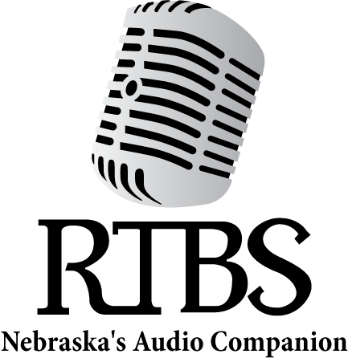

RTBS Board Members RTBS Staff

Ralph Morocco, President Bob Goding, Vice President Kyle Soares, Treasurer Richard Harrington, Secretary Peggy Hall
Christy Jobman Adam Kuenning Naomi Marion Mark Nasser
Stephen Papenfuss, MD Michael Pflueger
Jane Nielsen,
Executive Director Bekah Jerde,
Assistant Director Ryan Osentowski,
Station Manager Vic Wagner,
Volunteer Coordinator Michael Halula,
Board Operator

