
THE BROADCASTER

R A D I O T A L K I N G B O O K S E R V I C E

APRIL 2026 NEWSLETTER │ 2025 ANNUAL REPORT

2025: A Year of Renovations
Team RTBS spent 2025 giving our four recording booths a much needed refresh. With improved soundproofing, upgraded technology, and a cleaner, simplified aesthetic, the space is welcoming and efficient. Volunteers are loving the expanded workspace. RTBN listeners benefit from the sharper, clearer sound quality of our unique programming. A big thank you to Shelterbelt Theatre for donating soundproofing panels for our project!

The control room, aka Program Director Ryan O’s office, was also updated. Unwieldy, heavy desks and equipment racks were replaced with new furniture. Older sound equipment was taken out to further improve our overall broadcast sound. Finally, some paint, elbow grease, and new soundproofing made the soundboard area look and sound brand new. Shout out to Jim Ducey for helping streamline our studio equipment and technology.

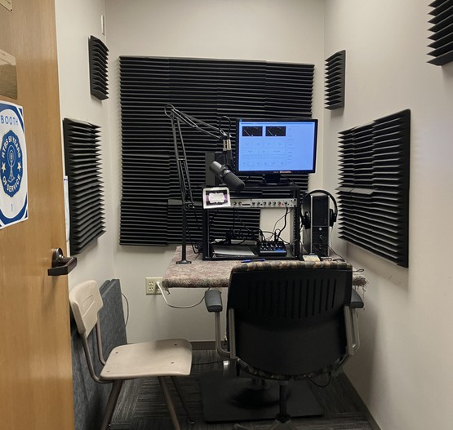
B E F O R E
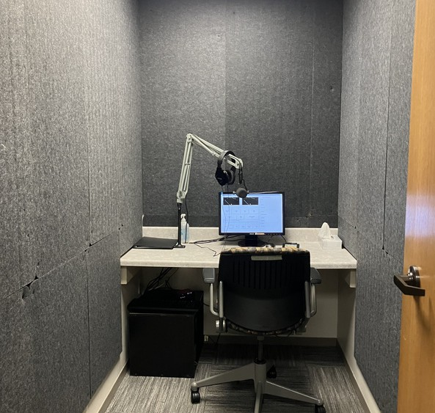
A F T E R

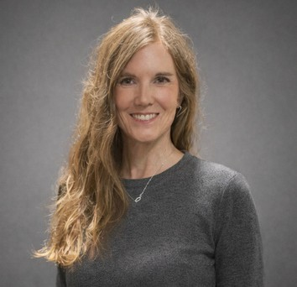
S T E P H P A T Z E R

NEW Team Member Alert!
Radio Talking Book Services’ new Communications Director, Steph Patzer, brings 23 years of experience in education, most recently as a special education teacher at Glenwood Middle School. She also owned Second Helpings Boutique, where she shared her upcycled art at Junkstock for a decade. Since joining the team in November, Steph has been enjoying getting to know the volunteers and growing into her new role.

Steph also volunteers regularly as a wardrobe dresser backstage at the Omaha Community Playhouse. In her spare time, she enjoys hot yoga, theater, social justice circles, reading, movies, live music, and cooking. She lives with her partner of 27 years, Craig, their dog Hobbz, and is the proud mom of two adult sons, Hank (24) and Sawyer
(21). Steph is a vibrant, energetic addition to Team RTBS!


MARK YOUR CALENDARS!!
Radio Talking Book Service is excited to announce we will be holding our 10th Annual Wining in the Dark at Nosh Wine Lounge! Test your taste buds with wines from around the world in a tasting and delight in delectable delicacies created for your pleasure by the chef at Nosh Wine Lounge.
There will bountiful raffle baskets full of goodies from friends and local businesses. We have one raffle dedicated entirely to local Nebraska authors and/or themes.
WHEN:
Sunday, April 19
4 to 6 p.m. WHERE:
Nosh Wine Lounge
1006 Dodge Street, Omaha Get your tickets today!
Seating is limited. Please purchase tickets by April 17th at rtbs.org or call 402-572-3003 to RSVP. Tickets are $80/person including gratuity, raffle entry, and a donation to RTBS.
Sponsorship opportunities available; contact Bekah at 402-572-3003.

SAVE THE DATES!! DO GOOD DAYS ARE April 22-25
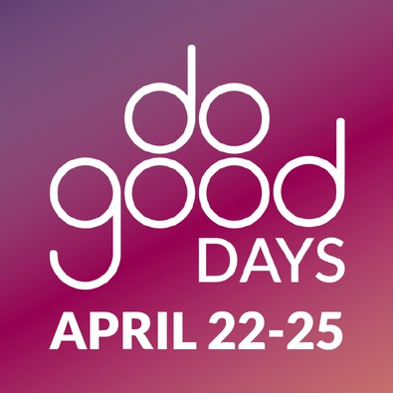
Join in SHARE Do Good Days, April 22-25! These 4 days are focused on all forms of support for local causes, and we can’t wait to see what
the Omaha metro can do when we give together for more than one day!

Team RTBS is excited for our Community Read-a-Book-a-thon during Do Good Days! We are inviting folks to pop in to read a chapter (or two!) of a Nebraska authored book with a goal to finish recording the book in three days to broadcast on-air for our listeners!

Do Good Days makes it easy to support us with your dollars – and more!

Visit shareomaha.org/nonprofit/radio-talking-book-service-inc to learn more!

APRIL VOLUNTEER SPOTLIGHT:
VOLUNTEER SPOTLIGHTS
M A R C H 2 0 2 6 : M I K E M I L L E R

F E B R U A R Y 2 0 2 6 : T O D D K E N N E D Y

J A N U A R Y 2 0 2 6 : P A T T Y S C H M I T Z

D E C E M B E R 2 0 2 5 : P A U L M U R P H Y

N O V E M B E R 2 0 2 5 : R O B I N C A R T E R

O C T O B E R 2 0 2 5 :
P H I L L I P W I L D E R

S E P T E M B E R 2 0 2 5 : A N N E M O R G A N

A U G U S T 2 0 2 5 : C H U C K J E N S E N

J U L Y 2 0 2 5 :
S U S A N B E E G H L Y

J U N E 2 0 2 5 : M A R K K L I N E

M A Y 2 0 2 5 : B A R B R U S E R
ELAINE CHAPIN
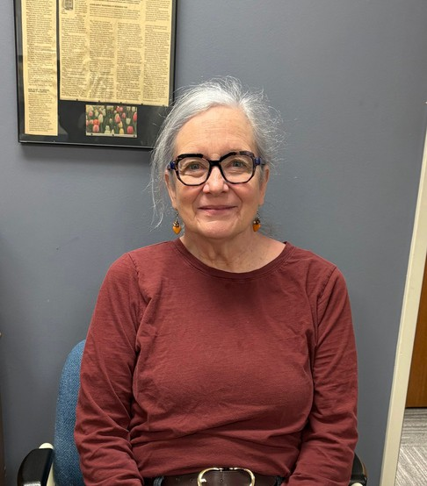
Team RTBS likes to think of Elaine Chapin as a lost treasure who was found again. Just when we think she may be gone forever, she returns to us, shinier than ever. Elaine has been volunteering for us off and on for 37 years. Sometimes, life happens and she has to take a step back. Lucky for us, Elaine always finds her way back to RTBS again!
She was born in the hill country of western Pennsylvania, then spent her formative years in various New England states before attending college at Salem State. Elaine has held many jobs over the course of her life, including that of a high school English teacher, a corporate trainer, a paralegal and a stay-at-home mother. She says she feels that she has lived several lifetimes in the span of one.
In 1989, her husband was transferred to Offutt Air Force Base, and she began her long stay in Omaha. She raised two adopted daughters here and now has seven grandkids. In her spare time, she loves reading, crocheting and music. She plays both the piano and violin, though she admits that she’s pretty rusty.
Elaine has been reading aloud since she was a child reading to her siblings, so she sounds like a natural at the mic. She has done it all for us in her 37 years, including the live reads, various magazines, Culture Quickies and even textbooks for our Listening Link program. Currently, you can hear her every Tuesday morning at 8AM, repeated Saturdays at 1PM, reading the North Central Nebraska Newspapers. Tune in to hear her interview with Ryan O on Friday, April 17 at 5:45pm or Saturday, April 25 at 12:15pm or find it on our podcast page.
THANK YOU FOR YOUR SERVICE,
CAMI RAWLINGS!

BEST WISHES ON YOUR NEW ADVENTURES!

BY-RYAN OSENTOWSKI, PROGRAM DIRECTOR

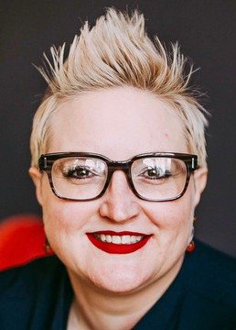
BEKAH JERDE EXECUTIVE DIRECTOR

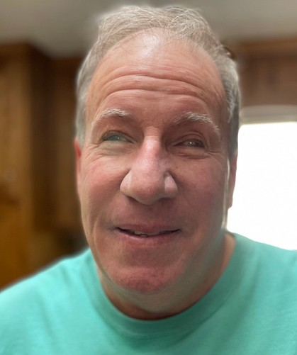
BOB BURNS BOARD CHAIR

DIRECTOR'S CORNER
2025 was a year filled with uncertainty and anxiety for so many nonprofit organizations. RTBS was no exception but with a dedicated staff, supportive board, extraordinary volunteers, generous donors, and an unrelenting spirit of service, we made it through. Thank you all for your amazing support!
RTBS has a commitment to provide the best quality programming to our 12,992 listeners across Nebraska. To that end, a generous donation of soundproofing panels from Shelterbelt Theatre inspired a refurbishment of our four recording booths and control room. Out came wobbly tables and old furniture, replaced by countertops, a new desk and equipment rack that provide a spacious experience for our volunteers and our program director. Outdated sound equipment was replaced, ensuring an improved sound for our broadcast.
2026 will be a year of change for RTBS. April brings a new program, Storytellers, where volunteers will read to memory care residents in small groups or one on one. RTBS will also be embarking on a name change spurred by our growth and evolution over 52 years. Stay tuned for all the details!

A NOTE FROM THE CHAIRMAN
RTBS had a successful 2025. We followed up our 50th anniversary year by continuing our positive momentum. We navigated the changing conditions with National Public Radio with no change in our services. The studio at RTBS got a face lift and a boost in the quality of our technology and sound production. As our population ages, the need for the essential services RTBS provides-critical news, vital health information, delightful entertainment, and audio description of local arts events-continues to grow.
As Board chair, I want to thank the volunteers whose generous donations of time and talent make our programming possible. I would also like to thank our listeners, the foundations and compassionate donors who selflessly support our mission, along with the individuals of our RTBS family who together make it possible for us to continue to deliver the news and programs that our listeners rely on.
Finally, I would like to thank our incredible staff, Bekah, Ryan, Stephanie, and Michael, who do an amazing job of maintaining a high standard of delivering our services to our listeners. Stephanie Patzer came on board in November and is doing a great job as Communications Director.

DONATIONS: April 2025-March 2026

CORPORATE/FOUNDATIONS

Alan & Marcia Baer Foundation Ameriprise Financial
Brasch Designated Fund Back 2 Health
Earl & Rose Berkey Charitable Fund Cari Sommer Charitable Fund Caring For People Services
Community Foundation for Western Iowa Cox Charities
Dixon Family Foundation
Edward & Lida Robinson Charitable Trust Enterprise Holdings Foundation
Ethel S. Abbott Charitable Foundation Farm Credit Services of America James P. & Anne C. Foley Fund
Ike & Roz Friedman Foundation Google
Hawks Foundation iHeart Media
JK Barker Foundation Immanuel Vision Foundation Kohll's Vesta Comapanions Kroger/Dillon Stores
Lincoln Financial Foundation The Lozier Foundation Manota E. Simon Foundation
Marshall & Mary Brondum Special Assistance Foundation The Milton S. & Corinne N. Livingston Foundation
Retina Center of Nebraska, P.C. Robert Herman Storz Foundation Security National Bank
The Sherwood Foundation Steinhart Foundation Webster Family Foundation William R. Patrick Foundation
ORGANIZATIONS/COMMUNITY GROUPS

Anastasis Theatre Aurora Lions Club Blue Barn Theater Clay Center Lions Club
Columbus Noon Lions Club Common Senses
Crete Lions Club Gordon Lions Club
Lied Center for the Performing Arts Murdock Lions Club
Nebraska Lions Foundation Offutt Officers Spouses Club Ogallala Lions Club
Omaha Association of the Blind Omaha Community Playhouse Omaha Performing Arts Omaha Symphony
Omaha Westside Lions Club Outlook Nebraska
Pierce Lions Club
Presbyterian Women in the Congregation Rose Theater
Scottsbluff-Gering Lions Club
St James United Methodist Women Sutton Lions Club
Tekamah Lions Club The Joslyn
Thrivent Financial
Voice Corps Reading Service Wallace Lions Club
UNDERWRITING
Eldercare Resource Handbook Seniors Blue Book
University of Nebraska Foundation

WINING IN THE DARK 2025 SPONSORS INDIVIDUALS

David & Jane Offutt Frontier Bank
Identity Marketing Group Bonnie K. Jerde
Outlook Enrichment
Matt Jetter-Medicare Insurance Solutions Loretta McNally-eXp Realty
Sigmond Financial of Raymond James All of Us Together
Emspace + Lovgren
Lori Hubbell, Realtor-Better Homes & Gardens RDG Planning and Design
Deb Ady
Jere Ames-Johnson Joanne Amoura Jon Anderson Anonymous Howard Bachman
Zac Baer & Brian Bartels Kenneth Barjenbruch Laura Beth Barr
Mildred Bartling Bob Bastarache

INDIVIDUALS INDIVIDUALS INDIVIDUALS INDIVIDUALS

Mik Baugh Susan Beeghly Kaye Bellino Sandra Bianchi Liz Blanke
Tom & Patrica Blasing Patty Bogatz
Joni & Bill Bollinger Melodee Bock Mikell Bowsman
Pat Brennan
Christina Frost
John & Elizabeth Fullerton Robert Fullerton
Scott & Tricia Fullerton Ellen Gaherty
Tom Garvey Sue Goding Polly Goecke Mike Gordon Jocelynn Gray
Sherri Green
Lorene Larsen Katie LeDoux Cynthia Lee Wendy Leitch Ed Leslie Lenora Levin
Lori Livingston-Hubbell Judd Lyons
Yano Mangiameli David Marsh
Randell Martin
Stephen & Jan Papenfuss Stephanie Patzer
Nancy Pawloski Tim & April Pearson Connie Pera Patricia Perry
John Phillips Sara Planck Kristal Platt
Jon & Dorothy Polan Mike Prenger

Judith & Steve Broghammer Donna Grimm
Amy Mather
Michelle Rankin

Susan Bronczyk Judy Brooks
Bob & Samala Brown
Jeffery Grinnell Pam Gude
Jeff Hansen
Rhonda Matney Tessa Matthey Erin McArthur
Carol Ravnsborg Melissa Ray Francie Rebolloso

John & Rosemary Brownrigg Michael & Britt Hanson
Annastacia McCarty
Daniel & Annie Rezac

Greg & Sue Bruening Mark Bulger
Sue Burger Robert Burns Teri Cain
Jim Carlson Christine Cary Cami Rawlings Jill Chleborad
Phyllis & Norman Choat Pamula Clifford Michael Combs Margaret Conley
Laura Cooper Lynn Marie Corbeil Karen Cote
Alistair Cullum
James & Cynthia Currie Carol & John Dennison Rita Deveny
Lisa Diederich Tami Doll
Melinda Dominguez Marie Dougherty Marina Drake
Dawn & Michael Drey Ron & Crystal Drey Robert & Phyllis Dunne Jim Ely
Malia Emary Jean English Charles Erickson Joe Ernst
Lorene & Jim Fiala Ken Fischer Nancy Flearl
Lawrence & Joan Friend
Dick Harrington Elizabeth Harvey Monica Hickman Walt Hively Lindsey Holley Nancy Holloran Donna Houghton Tom Howe
Jeff Hubka
David Huelsmann Edith Hummel Sharon Ishii-Jordan Rusty Jensen Bonnie K. Jerde Matt Jetter
Ardith Johnson Mary Johnson Kim Jubenville
Becca & Corey Kautz Irene Keenan
Susan Kelley Marilee Kelly Todd Kennedy Stephanie Kidd John Kieran Vickey Kleinsmith Emily Klimek Tara Knapp
Shirley Knudtson Family Diane Kohout
John Krajicek Barbara Kuhn Nancy Kurtenbach Peter Kwasa
Larry Labens David Laferla
Dick & Linda LaRue
Edward McCarty Tom McCaugherty Lynn McCormack Janet McCrae Jerome McGinty Catherine McGowan Loretta McNally
Linda & Thomas Mertz Sherry Micek
John & Pam Miller Mark & Carolyn Miller Rick Miner
Monica Mora-Handlos Anne Morgan
Ralph Morocco Sue Mouttet
William & Elizabeth Mulligan Paul Murphy
Kathy Mussack Mark Nasser Jane Nielsen Jessica Nitsch Sheri Noar Donald Noonan LInda Noonan Patrick Noonan Sharon Nova John Nownes
R.E. Nystrom
Joseph & Kathy O'Connor David Offutt
Jane Onken-Roberts & Jim Roberts
Karen Osentowski Ryan Osentowski Dolores Ostrom Sara Paape
Marty Riemenschneider Jo Roberts
Laura Romito Barbara Ruser Patty Schmitz Kelle Scott
Larry & Judy Seger Linda Severin
Tom & Sue Sheeren John Shepherd Mike Sigmond Steve Sleeper
Arlis Smidt
Melissa Whittle Smith MeMe & Darv Smith Nancy Smith
Gloria Sorensen Joselyn Kay Springer Karen Stander
Kathleen Steinauer Smith Rick Stone
Chris & Barb Stratman Willa Jean Stutheit David Sutherland Barbara Switzer Janette Taylor Heather Tedesco Sheryl Thomas
Linda Todd Kaye Travnicek Deb Trivitt
Don Van Moorleghem Terry Veylupek
Tom & Bev Vitamvas Lois & Harris Voss Marialyce Walsh Louie Warren
Anne Wattles

INDIVIDUALS

Warren K. Weber
Thomas & Lorraine Whitaker Jason Whitney
Cynthia Wiebold Laurel Wiegand David Wiesman Sally Wilhelm Brooke Williams Steven Willoughby Laura Wilwerding Alfred Wise
Jenny Wulff
John & Sara Young Robert Zaback Sandra Zdan Michelle Zych
GIFTS IN HONOR OF

Barbara Anderson Jimmy Brasch Emma & Will Scott Erickson Michael Halula Bekah Jerde
Pat Jones
Harold Kosowsky Rolf Kuhlman
Ed Leslie Elijah Massey
Rhonda Matney
GIFTS IN HONOR OF
Lynn McCormack Janet McCrae Ralph Morocco Don Nagel
Ryan Osentowski Steph Patzer
Bill Rasmussen Cami Rawlings Mona Jean Roberts RTBS Volunteers RTBS Staff
GIFTS IN MEMORY OF
Audrey Wright Anderson & George C. Anderson
Tracy Austin Dave Leon Bandi Mildred Bartling Ednamae Beaty Robert T. Bianchi Ina Bock
Sarah Bogatz
Jack & Sheila Brownrigg Josephine Curro
Betty Dougherty Lucille Dunlavy Bernice & Isadore Falk George & Clare Flecky Dr. Craig Fullerton Steve Hahn
Wanda & Myron Harris
GIFTS IN MEMORY OF
Lyle Hagedorn Mary Henney Micah Jerde Elizabeth Kiewit Shirley Knudtson Urdine Lancaster Toby Martinez, Sr Elaine McCrae Janet McCrae William G. Meyers Trudy Miller
Shirley (O'Connor) Noar Mary L. Noonan Richard Osentowski Andrea Otness
Alice Sullivan Perry LaVon & Kay Peterson Bill Pfeiffer
Gwen Rasmussen
Mary Lee (Gallagher) Reznicek Janet Smith
Eloise Tomcraft Richard Thomas Alice Wagoner Tom Walsh Donald H. Weber Georgia Wheeler Mae Wittwer John Wick
Ron Witt Dick Zlab

Radio Talking Book Service thanks everyone for their generous support!!

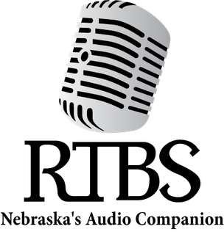

RTBS Board Members R TBS Staff

Robert Burns, President Melissa Smith, Vice President Kyle Soares, Treasurer
Rachel Carver, Secretary Richard Harrington John Miller
Ralph Morocco Stephen Papenfuss, MD Michael Pflueger Francie Rebolloso
Bekah Jerde, Executive Director
Ryan Osentowski, Program Director
Stephanie Patzer Communications Director
Michael Halula, Board Operator

