
THE BROADCASTER
R A D I O T A L K I N G B O O K S E R V I C E

APRIL 2020 NEWS L ET T ER │ 201 9 ANNUAL REPORT

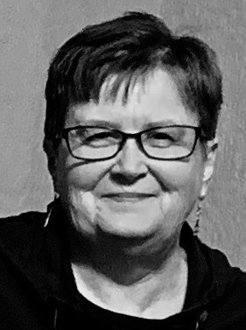
BREAKING NEWS!
JOIN OUR TEAM OF
AMAZING VOLUNTEERS AND BRING THE PRINTED WORD TO LIFE FOR OUR LISTENERS! VISIT OUR WEBSITE, RTBS.ORG, TO FILL OUT A VOLUNTEER APPLICATION OR CALL MEME TODAY AT (402) 572-3003!

VOLUNTEER COORDINATOR
MEME SMITH

R T B S W E L C O M E S N E W
V O L U N T E E R C O O R D I N A T O R !

It was a long and winding road that brought me here to my position as the Volunteer Coordinator at Radio Talking Book Service. I was born in South Dakota, but grew up primarily on the West and East Coasts.
Wherever I was, I always liked to have reading material with me. Through a very circuitous route, I eventually found my calling as a Library Director and thoroughly enjoyed it before retiring in 2017.

My husband and I moved to Omaha at that time and spent a couple winters hibernating before deciding to volunteer and get out and meet people. Because reading and promoting reading has always been a big part of my life, RTBS was a great match for me.

I feel like I was in the right place at the right time when the Volunteer Coordinator position became available and I am very fortunate to now be working with so many wonderful people. Other pursuits besides reading are, bicycling, sewing and crocheting, and of course, spending time with family and friends.

MARK YOUR CALENDARS!!
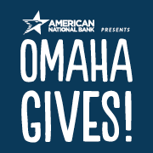
OMAHA GIVES IS MAY 20!!

Radio Talking Book Service is proud to be participating in the 8th annual Omaha Gives!, a 24-hour charitable challenge organized by the Omaha Community Foundation. The online giving holiday will take place May 20 from midnight to midnight. Mark your calendars because we will need your help! Schedule your gifts ahead of time or make donations throughout the day on Wednesday, May 20. Your gift, no matter the size, will go even further this year with matching funds!! Visit www.omahagives.org to find out how you can help support RTBS on May 20.


NEWS FLASH(ES)!!

RTBS thanks everyone who participated in Omaha Gives 2019!
We hope this year is even more successful! Visit our website at www.rtbs.org for more information.
Please join RTBS on May 20 to meet our goal of $5,000 for Omaha Gives!.



NEW! Veterans Hour now features local publications AND is available on podcast!
Tune in on Saturdays at 2 pm or visit rtbs.org to listen on demand!
EXTRA! EXTRA! We added ALL
ten of our regional newspapers to our podcast options! Find our podcasts on our website or on
iTunes!
NEW PODCASTS!
Now you can listen to Community Conversations, Volunteer Spotlights, &
Community Calendar on your time!

Many thanks to those who made our 5th Annual Wining in the Dark a success! Keep your eye on our event calendar & join us next year!

APRIL VOLUNTEER SPOTLIGHT:
VOLUNTEER SPOTLIGHTS
M A R C H 2 0 2 0 :
M A D E L I N E W A R D

F E B R U A R Y 2 0 2 0 : E R I N V A N Z E E

J A N U A R Y 2 0 2 0 : P A U L O R W I G

D E C E M B E R 2 0 1 9 : D E A N N B R I G H T

N O V E M B E R 2 0 1 9 : M I K E G A H E R T Y

O C T O B E R 2 0 1 9 : R A L P H M O R O C C O

S E P T E M B E R 2 0 1 9 : J E A N N E G R A Y

A U G U S T 2 0 1 9 : W I L L S P E C H

J U L Y 2 0 1 9 :
G A R Y D I E T R I C H

J U N E 2 0 1 9 :
L I N D S E Y H O L L E Y

M A Y 2 0 1 9 :
L A U R A B E T H B A R R
PAUL MURPHY

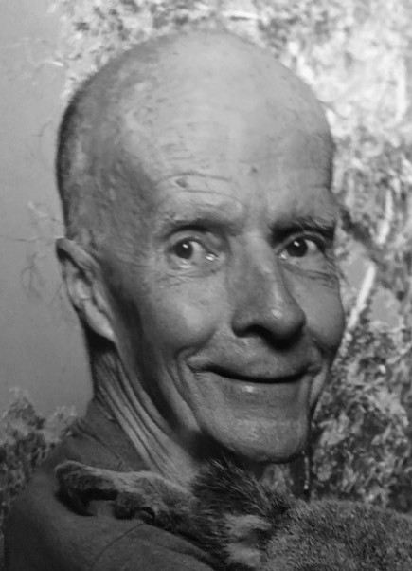
Paul Murphy is a well-traveled man. Born in Scottsbluff, he subsequently lived in Cheyenne, Sacramento, San Antonio, Denver, and Oklahoma before his career in the U.S. Air Force led him to Offutt Air Force Base in 1970. He was scheduled to be sent to South Vietnam in 1971, but his first wife’s pregnancy allowed him to be removed from active duty.

Paul finally put down roots in Omaha, getting a job with the city, which he held for over 39 years until his retirement. Paul continued to serve his country for 28 years with the National Guard. Paul lives with his second wife, Peg, in Omaha. He has four children from two marriages and eight grandchildren. He loves to spend his spare time long distance cycling and creating stain glass art. He has generously donated several of his creations for our annual Wining in the Dark fundraising event as auction items.

Paul fervently believes that the best way to get to know your community is to volunteer. He drives for the American Cancer Society and regularly works with HETRA. He has spent a total of 15 years reading for RTBS. He can currently be heard on Wednesday mornings reading the Lincoln Journal Star and Thursday afternoons reading the Scottsbluff Star Herald. He also reads the Topeka Capital Journal for the Audio Reader of Kansas every weekend.

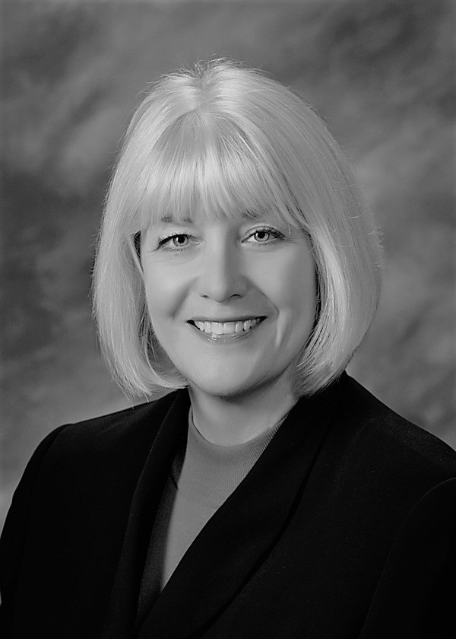
JANE NIELSEN EXECUTIVE DIRECTOR
DIRECTOR'S CORNER

Greetings! The RTBS Board of Directors and staff were blown away by the wonderful response of our volunteers when Covid-19 hit. RTBS ceased in-person volunteering in mid-March, and we now have 50 dedicated volunteers reading from home! In less than a week’s time, RTBS had transformed our cadre of volunteers into remote readers who continue to provide the vital, local programming our listeners rely on – now more than ever.

Amazingly, RTBS has not had to alter our program schedule as a result. The Omaha and Lincoln papers are recorded each day rather than read live in-studio. A weekly review of newspapers from across Nebraska and SW Iowa continues along with grocery and department store ads, magazines, and more—all are still being broadcast to our faithful listeners. We have provided restaurant takeout and delivery options, new options for church services, a daily Covid-19 update listing resources, and a modified weekly Community Calendar with the most up-to-date listings for access to food, services, and assistance. I am so thankful and proud to be part of the RTBS Team!

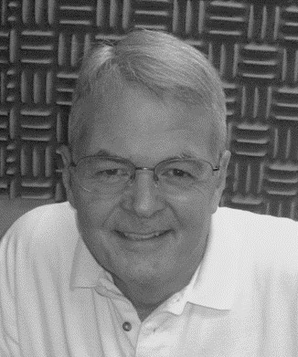

RALPH MOROCCO BOARD CHAIR

A NOTE FROM THE CHAIRMAN

I hope this message finds you healthy. Since our studios have closed, we have had to make some changes to our regular programming.
But new technologies are allowing us to serve you, even though many of our recordings are now done in the bedrooms or at the kitchen tables of our dedicated corps of volunteers. Our smartphones, voice recorders and home computer microphones are allowing us to continue to bring you the programs you count on. And in the unprecedented and uncertain times we are living in, there is great comfort in knowing that the sources of information we rely on for critical information will be there for us.

Radio Talking Book has been around for more than 45 years, and
in all that time we have never faced a challenge like the one we face today. As chair of the Board of Directors, I especially want to thank our dedicated staff team for the incredible work they are doing to meet these challenges. I also want to thank our amazing group of
volunteer readers, who are now doing their own recording without benefit of studio equipment. I’d also like to thank our donors, both large and small, who are allowing us to do the important work of providing the news and information you count on in an accessible format. Thank you, and stay well!

DONATIONS: April 2019-March 2020

CORPORATE/FOUNDATIONS

Adah & Leon Millard Foundation Back2Health
Bank of the West
Cari Sommer Charitble Fund Cooper Foundation
Dixon Family Foundation Eagle Hollow Haunt
Edward & Lida Robinson Charitable Trust Ethel Abbott Foundation
Gilbert & Martha Hitchcock Foundation Golden Years
Grant Dental Plaza
Hawks Foundation-Rhonda and Howard Hawks Home Instead Senior Care Foundation
Houlden Family LLC
Ike & Roz Friedman Foundation Immanuel Vision Foundation JK Barker Foundation
Kroger Stores
Lexington Community Foundation Manota E. Simon Foundation
Marshall & Mary Brondum Special Assistance Foundation Midlands Community Foundation
Milton & Corinne Livingston Foundation Nosh Wine Bar and Restaurant
Oliver & Ferrol Barklage Foundation Papillion Community Foundation Retina Center of Nebraska
Robert Storz Foundation Rupert Dunklau Foundation Sherwood Foundation Steinhart Foundation Webster Family Foundation William R. Patrick Foundation
WINING IN THE DARK SPONSORS
Security National Bank
Paula Dietering, Prairie Wealth Advisors Bonnie Jerde
Bank of the West Outlook Nebraska Identity Marketing Group Bland Cares Foundation
Matt Jetter, Medicare Insurance Solutions Immanuel Communities
Golden Years Senior Relocation Experts Oh-K Fast Print
ORGANIZATIONS/COMMUNITY GROUPS

American Association of University Women Battle Creek Lions Club
Bellevue Nature Club Bethany Lions Club Columbus Noon Lions Club Cook Lions Club
Crete Lions Club Fremont Lioness Club
I-80 Cosmopolitan Club IAAIS
John C. Fremont Lions Club Nebraska Lions Foundation Neligh Lions Club
Omaha Association of the Blind Omaha Westside Lions Club Papillion Area Lions Club
PEO Chapter EY PEO Chapter FY
Presbyterian Women in the Congregation Southwest Omaha Sertoma Club
St. James United Methodist Women Tekamah Lions Club
Wilcox Lioness Club
IN-KIND DONATIONS
Arby's • Ames Casey's
General Store • Papillion Chick-fil-a • Sorenson Dillon Stores
Dunkin Donuts • Papillion Facebook
Hy-Vee • Fort Street Hy-Vee • Papillion Jane Nielsen
Jimmy Johns • Sorenson KFC • Sorenson
Lowes • Papillion
Papillion Community Foundation Papillion Lions Club members Paul Orwig
Petit's Pastry
Sam's Club • Papillion Target • Sorenson Village Inn • Sorenson
UNDERWRITING
Hillcrest Heath Systems Outlook Nebraska Senior Blue Book

INDIVIDUALS INDIVIDUALS INDIVIDUALS INDIVIDUALS

Dorothy Abbott Deb Ady Karima Al-Absy Avis Anderson Roy Anderson Jon Anderson Anonymous
Howard Bachman Elizabeth Banset Ken Barjenbruch Melissa Barnett Mary Barnhart Laura Beth Barr
David & Marion Barran Bob Bastarache
Mike & Linda Bechtel Patti Bendgen
Tanya Benedict Lori Benton Laura Betz Sandra Bianchi Eric Bildt
Tom & Pat Blasing Harriet Bloemker Gary & Ann Bloemker Le Bloemker
Karen Coté Kim Crayne
Charlotte & Roger Curry Rita Cushenbery Claudia & Tony Deeb Lynn Denzler
Jodie DeSordi Jeri Dobos Tami Doll Steve Douglas Lucille Dunlavy
Tom Shomaker & Lori Ecklebe Gary Emenitove
Howard & Sharon Epstein Joe Ernst
Mary Ann Eusebio Maryfrances Evans Ginny Fallon Donna Aman
Donald & Sharene Felten Amy Feltz
Nancy Flearl
George & Kathleen Flock Fran Frauendorfer
Jason Frazier Christina Frist
Phyllis Heimann Angie Heller Brenda Hennigs
Lawrence Hernandez Iris Herse
Frank Herzog Monica Hickman Don Hieb
Walt Hively CJ Hohman
Helen Hohndorf Lindsey Holley Nancy Holloran Chris Homer Marise Hopkins Donna Houghton Kathy & Scott Hoyt David Huelsmann Kim Huff
Zoe Ann Huffman Linda Hughes Tim Hurley Naomi Isaac
Ken Janicek
Bekah Jerde & Bart Vargas Bonnie & Doug Jerde
Benjamin Lamberty Hans Langner Wanda Lanoue Sharon Larson Philip & Cynthia Lee Joanie Lehr
Brian Leichner Nancy Lepo Ed Leslie Lenora Levin Mary Lewis
Kenneth Mahaffey Edward Malashock Jason Mance
Bill Manning Joe Marino Naomi Marion Deb Marshall Jack Martin
Drs. Bob & Terri Mathews Julie McCarty
Lynn McCormack Bob McCoy
Janet McCrae Cathy McGowan Melissa McMullen

Janet & Lowell Bloemker Jack Frost
Matt Jetter
Nancy Mead

Patty Bogatz Ann & Ray Boice Kathryn Bolie
Joni & Bill Bollinger Melissa Bradley Patrick Brennan Betty Brocker
Pat Brodersen Judy Brooks
John & Nancy Burch Sue Burger
Jean Butler Nick Calava Walter Canney Mary Carlson Kim Carlson Elaine Chapin John Chedester
Norman & Phyllis Choat Imogene Clements Pamula Clifford
Nancy Coffman Michael Combs Laura Cooper Steve Coram
Robert Fullerton
John & Betty Fullerton Scott & Tricia Fullerton Peter & Mary Gadzinski Mike & Ellen Gaherty Juliana Garza
Bob Goding Polly Goecke Jeanne Gray Sherri Green Joe Gregory Helen Griffith Jeff Grinnell Lynn Groff
Mary Grosserode Xochitl Gudino
Mary Henney Gurney Tena Hahn Rodriguez Peggy Hall
Wendy Hamilton Michael Hanson Richard Harrington Michaela & Brad Hart Elizabeth Harvey Amy Hatter
Christy Jobman Alan Johnson Denise Rauterkus Bret Johson
Dori Justine Greg Karst Evelyn Katz Susan Kelley Lisa Kelly Marilee Kelly John Kieran Milton Kleinberg
Vickey Kleinsmith Rita & John Klingman Peggy Knights Richard Koelling Colette Kramer
Marj Krawczyk Jack & Marie Kubat Adam Kuenning Barbara Kuhn Howard Kutler Dave Laferla
Sarah Laferla Marty LaLande
Peggy Menck
Tom & Linda Mertz Barbara Metz
Mark & Carolyn Miller Rick & Jane Miner Steve Minor
Ralph & Mikaelah Morocco Marleen Muenster
Julie Mund
Paul & Peg Murphy Kathy Mussack Mark Nasser
Tom Nelson Jane Nielsen Diane Nietfeldt Mary Noonan Neal Obermeyer
Jane Onken-Roberts Caitlin Osborn
Ryan Osentowski
Richard & Karen Osentowski Mary Osentowski
Jared Osentowski Chris Osentowski Dolores Ostrom

INDIVIDUALS INDIVIDUALS GIFTS IN HONOR OF GIFTS IN MEMORY OF

Dr. Stephen Papenfuss Ruth Parks
Andrea Pasquale Jeanne Patrick Kelley Patton Connie & Doug Pera
Larry & Jane Peterson Inez Petrie
Michael Pflueger Joze Pihlar
Mary Popp Katie Powers Judy Price
Carol Ravnsborg Daniel & Annie Rezac Mary Ann Richards
Marty Riemenschnieder Todd Robinson
John Rogers Laura Romito
Philipp & Lauren Ruhe Carol Russell
Robert Saegar Samantha Sandberg Rick Schmid
Deb Schmidt Doug Schroder Larry & Judy Seger
Tom & Sue Sheeren Dr. John Shepherd Curt Siemers
Steve Sleeper MeMe Smith Marjorie Sneller Kyle Soares Phyllis Solomon
Renee Southworth Donald & Carolyn Srajes Karen Stander
John Stevens Sally Stich Rick Stone
Maureen Strain
Chris & Barb Stratman James Surber
David Sutherland
Dr. Terry & Marilyn Theis Anita Theophilus
Sheryl Thomas David Thompson Larry Thornton Catherine Tierney Ann Tjaden
Sally Stich
Ralph & Gay Tosti Kay Travnicek Deb Trivitt
Harry Vacek Erin Van Zee Linda Vencil Terry Veylupek
Tom & Bev Vitamvas Lois Voss
Kara Wade-O'Connor Vic Wagner
Tom Walsh Madeline Ward Cammy Watkins Sarah Watson Steve Wehrbein Jean Wheatcraft Jason Whitney Grant Wieseler David Wiesman Judy Wigton Pauline Wilcox Sally Wilhem Esther Williamson Steven Willoughby Matt & Annie Wise Fran Witt
Dolores Wolsleben
Sara & John Young
Deb Ady
All Volunteers
All with Vision Problems Arlene
Red & Esther Bechtel Gale Bowers
Margie Carney Lucille Dunlavy Josephine Gregory Ed & Janet Guthrie Mildred Hansen Wanda V. Harris Bekah Jerde
Sybil Mahan Sally Malashock Elijah Massey Janet McCrae Ralph Morocco
My Book Reading Family Jane Nielsen
Phyllis Olson’s 86th Birthday Ryan Osentowski
Our grandchildren-
John, Mary Grace, Julia, Liz, Isam, Emily, & Ryan
Gene Smoler Paul Stebbins
The Wonderful Staff of RTBS GIFTS IN MEMORY OF
Bob Anderson Jack Barnhart Ray Barr
Otto, Roger, & Harold Bartz Ednamae Natzke Beaty Sarah Bogatz
Frank Bramhall Frank Calava Kenneth Carlson Agnes Clark Eloise Craft Josephine Curro
Dr. Donald Cushenbery
Bernice & Isadore Falk Fr. Phil Fisher, SJ Craig Fullerton
Myrna Grayson Myron A. Harris Betty Hohndorf Elizabeth Kiewit Jean Knowles Lou Kramer
Dr. James Krier Pat Kurfman Pauline Landman Eli Lanoue Robert Manning LaVerna Marion Elaine McCrae Betty Minor
My Daughter,
Debbie Misenhelter Janice "Jan" Moritz Norma & Bob Mountain John Muenster
Milford & Ethel Murphy Hayley Nemmers Andrea Otness
LaVon "Pete" & Kay Peterson Bryce Pfeiffer
Marjorie Rynaski Powers Michael “Mike” Rice Esther Simon
Kyle Solomon
Rochelle "Rocki" Stevens Dr. J.E. & Ellen Stevens Robin Tosti
Isabelle Trobough Darlene Veylupek Alice Wagoner Georgia Wheeler Anna Wiesman Dan Wilcox
Ron Witt Dick Zlab Don Zurcher

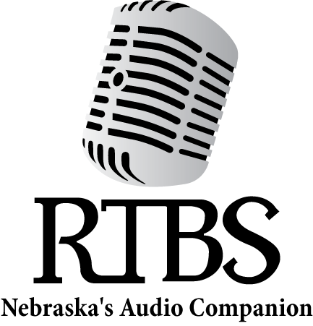
Radio Talking Book Service thanks everyone for their generous support!!

RTBS Board Members RTBS Staff

Ralph Morocco, President Bob Goding, Vice President Kyle Soares, Treasurer Richard Harrington, Secretary Christopher Connor, OD Pastor Peggy Hall
Naomi Marion Mark Nasser
Stephen Papenfuss, MD Michael Pflueger
Jane Nielsen,
Executive Director Bekah Jerde,
Assistant Director Ryan Osentowski,
Station Manager MeMe Smith,
Volunteer Coordinator Michael Halula,
Board Operator

