THE BROADCASTER
R A D I O T A L K I N G B O O K S E R V I C E

APRIL 2022 NEWSLETTER │ 2021 ANNUAL REPORT

A Fond Farewell to Jane!
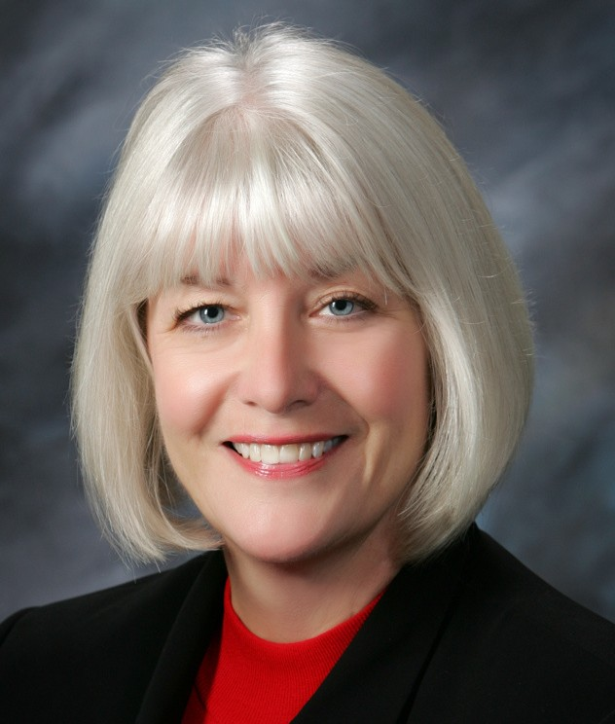
In December 2021, RTBS wished Jane Nielsen happy trails in her retirement after 5 years of leadership! A note from Jane:
"Farewell and Thank YOU! It has been a joy, an honor, and a privilege to work with amazing Volunteers, a fabulous Team, and wonderful Board Members since October of 2016! I am excited for my next chapter--retirement--doing whatever I want whenever I want! Travel to see family and friends, read, walk, play the piano, Lions Club, and my church activities-- and seek new adventures!
My very Best Wishes to Bekah, Ryan, Michael and Cami-the sky is the limit-can't wait to see what the next chapter holds for RTBS! With much appreciation for all YOU do!"
-JANE NIELSEN

NEW Team Member Alert!
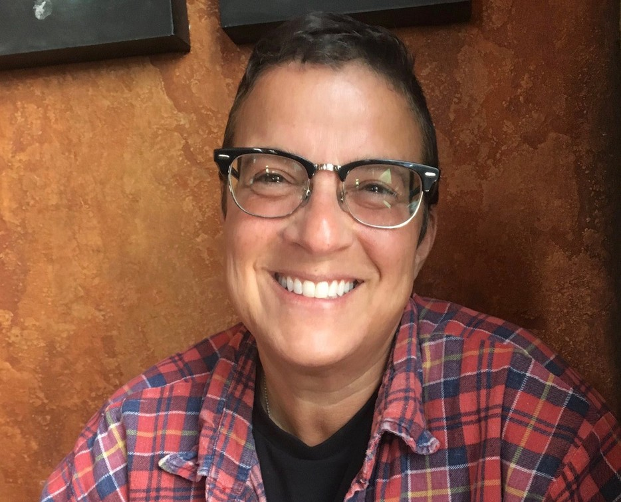
RTBS’ new Communcations Director, Cami Cavanaugh Rawlings, is no stranger to radio. She spent over 20+ years providing the most accurate live radio and tv traffic reports in Omaha as Cami Carlisle. After leaving radio in 2016 for a new career in the nonprofit world, Cami’s nonprofit work lead her right back to radio at RTBS. In her new role, Cami brings years of broadcasting experience to the team as well as her wide knowledge of nonprofit how to.
Cami is on the Omaha Girls Rock Executive Board and also volunteers for OGR’s summer camps as a band coach. In her spare time, Cami likes to rock out with her band, Bathtub Maria, and enjoys spending time in the garden with her wife, Shell. They have 5 crazy cats and 2 elderly dachshunds that take up the remainder of their time.

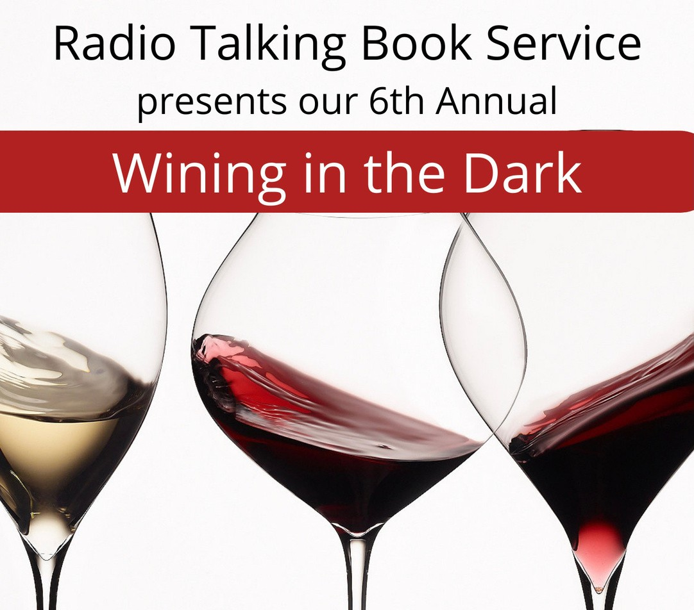MARK YOUR CALENDARS!!
Radio Talking Book Service is excited to announce we will be holding our 6th Annual Wining in the Dark at Nosh Wine Lounge! Test your taste buds with wines from around the world in a blindfolded tasting and delight in delectable delicacies created for your pleasure by the chef at Nosh Wine Lounge.

WHEN:
Sunday, April 24
4 to 6 p.m.
WHERE:
Nosh Wine Lounge 1006 Dodge Street, Omaha
Get your tickets today!
There will be a raffle including a 6-month membership to Nosh's Wine Club! One of our multi-talented volunteers, Anita Jaynes, will be providing entertainment on her harp.
Seating is limited. Please purchase tickets by April 20 at rtbs.org or call 402-572-3003 to RSVP. Tickets are $75/person including gratuity, raffle entry, and a donation to RTBS.
Sponsorship opportunities available; contact Bekah at 402-572-3003.

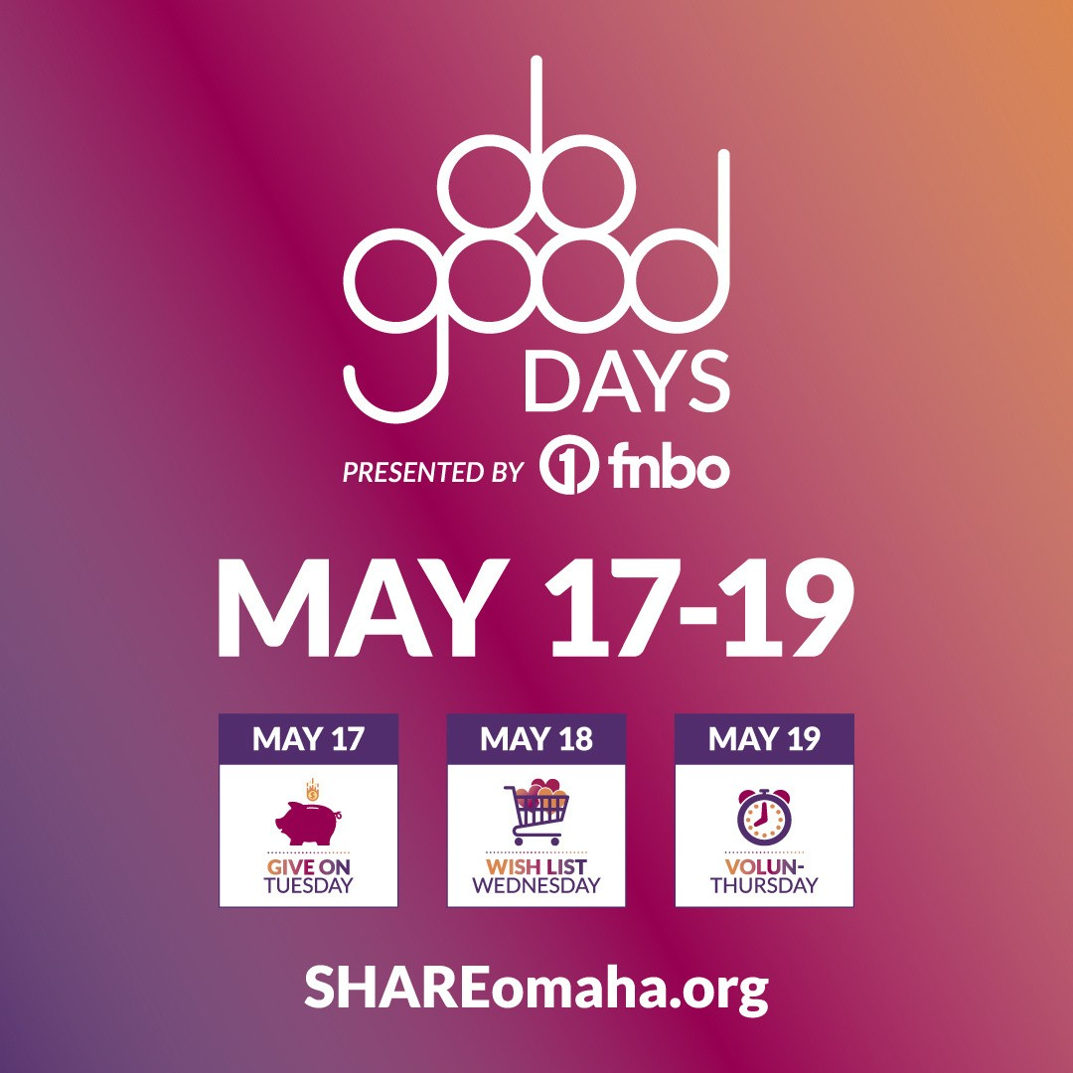SAVE THE DATES!! DO GOOD DAYS ARE MAY 17-19

Join in SHARE Omaha’s Do Good Days, May 17- 19, presented by FNBO. These 3 days are focused on all forms of support for local causes and we can’t wait to see what the Omaha metro can do when we give together for more than one day!

Team RTBS will keep you posted about how you can bring the printed word to life during Do Good Days! There will be matching funds available during Do Good Days to make your donations go twice as far! Do Good Days makes it easy to support us with your dollars – and more!

Visit shareomaha.org/nonprofit/radio- talking-book-service-inc to learn more!

APRIL VOLUNTEER SPOTLIGHT:
VOLUNTEER SPOTLIGHTS
M A R C H 2 0 2 2 : S T E P H A N I E
M I S K E
F E B R U A R Y 2 0 2 2 : B I L L E V E R H A R T
J A N U A R Y 2 0 2 2 : N A N C Y D I R K S
D E C E M B E R 2 0 2 1 : S T E V E H A N K S
N O V E M B E R 2 0 2 1 : M I C H A E L A H A R T
O C T O B E R 2 0 2 1 :
B O B B A S T A R A C H E

S E P T E M B E R 2 0 2 1 : S U E B U R G E R

A U G U S T 2 0 2 1 : J O H N N O W N E S
M A Y 2 0 2 1 :
J E A N S I T T E R
SHARON ISHII-JORDAN
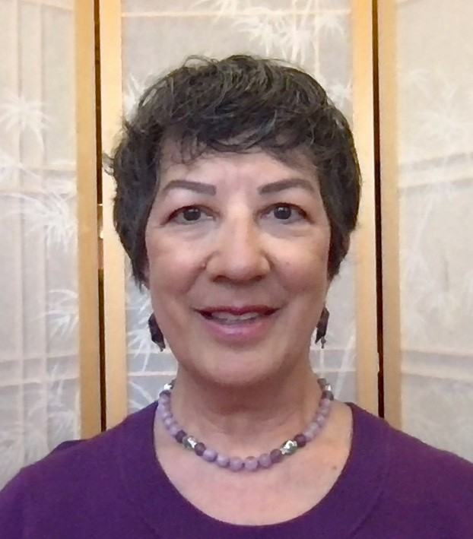
The smooth, reassuring voice of Sharon Ishii-Jordan is a ubiquitous presence on RTBS. She can be heard reading about science, health and technology, all subjects she cares a great deal about.
Raised in a military family, she grew up on three continents. She was born in Japan, lived at various U.S. military bases
where each of her four siblings were born, and spent time in Spain and Germany as a child before settling in Omaha for high school and college.
Like so many of her fellow volunteers, Sharon is a teacher. She specializes in English Language Learning and Special Education. Her teaching venues were as diverse as Omaha Public Schools, Creighton University, and a psychiatric hospital. She was also the Associate Dean of the College of Arts and Sciences at Creighton. She retired in 2015, but she wasn’t finished being an educator. She has been a substitute teacher at OPS as well as an ESL Mentor working with an Afghani refugee woman on behalf of Lutheran Family Services.
THANK YOU FOR YOUR SERVICE!
DEANN BRIGHT JUDY PRICE
In addition to RTBS, she donates much of her time to the Japanese-Americans Citizens League, as well as Saint Leo’s Catholic Church. She currently lives in Omaha with her husband and stays in close touch with her two adopted adult children and her granddaughter. Sharon has no pets, having never gotten over her husband’s refusal to allow her to own a Gila monster. You can hear Sharon Ishii-Jordan every Tuesday reading Science & Environment, as well as various segments of Health & Wellness and Bookshelf on RTBN.
IN MEMORY OF:
BILL MANNING TOM WALSH
BY-RYAN OSENTOWSKI, PROGRAM DIRECTOR

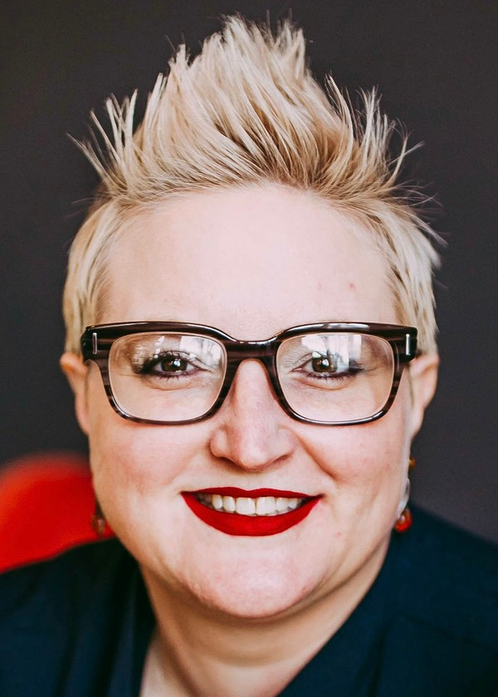
BEKAH JERDE EXECUTIVE DIRECTOR

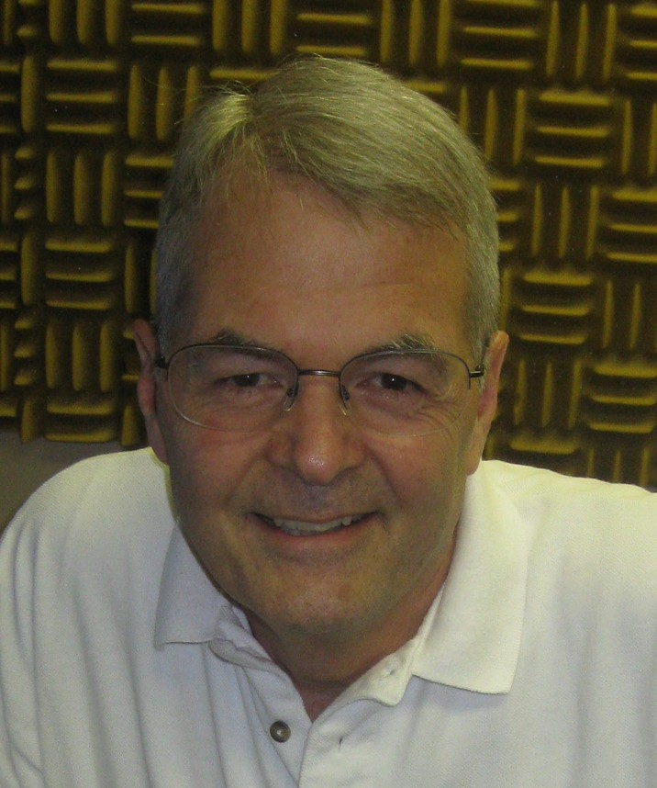
RALPH MOROCCO BOARD CHAIR

DIRECTOR'S CORNER
I am honored and excited to be selected as the new RTBS
Executive Director. I began my journey at RTBS as a volunteer in 2013 recording programs including Good Old Days, Consumer Information, and more. In 2015, I was hired as the Office Manager. Spring 2016 found me in the role of Interim Executive Director.
That fall, I became the Assistant Director, working with and learning so much from Jane Nielsen. I am excited to lead such an inspirational, amazing team: Ryan, Cami, and Michael!
With resilient and committed volunteers as well as access to necessary technology, RTBS rose to the challenges posed by the pandemic that have affected us all. RTBS spent 2021 navigating our cadre of volunteers, functioning as remote readers since March 2020, safely back into the studios. In 2022, RTBS will utilize a hybrid of in-person and remote readers to provide the vital, local programming our listeners rely on now more than ever!
2022 is off to a great start with more local, current programming being implemented and new connections being made. I cannot begin to express my gratitude and admiration for our dedicated, resilient staff and volunteers, ensuring our listeners access to RTBS programming. For all the ways YOU support RTBS, thank you!

A NOTE FROM THE CHAIRMAN
As coronavirus vaccines protect more of us, RTBS has continued to
adapt to pandemic-related changes. Last year, our dedicated volunteers were reading from home, as our talented staff worked to keep our broadcasts coming and our volunteers and staff safe. Now, RTBS has accommodated improving circumstances, bringing back volunteers for on-site recording and live programming. Dedicated volunteers who were unable to record remotely, waited patiently, and many who had been off duty because our studios were closed have now returned to the delight of our listeners.
In the past year, we also bid Godspeed to Jane Nielsen, who retired after five years of dedicated RTBS leadership. The RTBS Board was fortunate to be able to appoint Bekah Jerde, who had served five years as assistant director, to fill the position of Executive Director. We look forward to Bekah’s leadership to help us bring the printed word to life for our listeners.
As Board chair, I also want to thank the volunteers whose generous donations of time and talent make our programming possible. I would also like to thank our donors – the Omaha Association of the Blind, the foundations, individuals, and listeners – who have helped us to meet the needs those who count on us for the news and information that is so critically important at this time.

DONATIONS: April 2021-March 2022

CORPORATE/FOUNDATIONS

Back 2 Health Bank of the West
Cari Sommer Charitable Fund Dixon Family Foundation
Edward & Lida Robinson Charitable Trust Emspace, Inc.
Ethel S. Abbott Charitable Foundation
Gilbert M. and Martha H. Hitchcock Foundation The Hawks Foundation
Hillcrest Health Systems, Inc.
Home Instead Senior Care Foundation Ike & Roz Friedman Foundation Immanuel Vision Foundation
JK Barker Foundation Kroger / Dillon Stores
Manota E. Simon Foundation
Marshall and Mary Brondum Special Assistance Foundation, Inc.
The Max and Victoria Dreyfus Foundation, Inc. Midlands Community Foundation
The Milton S. and Corinne N. Livingston Foundation Nebraska Lions Foundation
Oliver and Ferrol Barklage Foundation Trust Omaha Association of the Blind
Outlook Nebraska, Inc Pettit's Bakery
Retina Center of Nebraska, P.C. Robert Herman Storz Foundation Rupert Dunklau Foundation, Inc. The Steinhart Foundation, Inc.
Thrivent Financial University of Ne/Omaha Webster Family Foundation
WINING IN THE DARK 2022 SPONSORS

Bonnie Jerde EmSpace + Lovgren
Golden Years Senior Relocation LLC Outlook Collaborative
Paula Dietering, Prairie Wealth Advisors The Brant Senior Living: Gretna

UNDERWRITING
CCA Home Care Hillcrest Heath Systems Outlook Enrichment Senior Blue Book
ORGANIZATIONS/COMMUNITY GROUPS

Aurora Lions Club Battle Creek Lions Club Clay Center Lions Club
Columbus Noon Lions Club Cook Lions Club
Crete Lions Club Gordon Lions Club
John C. Fremont Lions Club Neligh Lions Club
Ogallala Lions Club
Omaha Westside Lions Club Papillion Area Lions Club PEO Sisterhood Chapter EC Pierce Lions Club
Presbyterian Women in the Congregation Scottsbluff-Gering Lions Club
St James United Methodist Women Tekamah Lions Club
Wallace Lions Club

INDIVIDUALS
Dorothy Abbott Elizabeth Abel Deb Ady Karima Al-Absy Anonymous
Howard Bachman Elizabeth Banset Melissa Barnett Mary Barnhart Bob Bastarache MaryBelle Beach Jana Benitez
Lori Benton
Tom & Patricica Blasing Melodee Bock
Patty Bogatz Ann Boice
Joni & Bill Bollinger Opal Bosn
Ann & Pat Bowsman Pat Brennan
Susan Bronczyk Judy Brooks Bob Brown
John & Rosemary Brownrigg Greg & Sue Bruening
Sonita Buddi Jeffrey Bullington

INDIVIDUALS INDIVIDUALS INDIVIDUALS INDIVIDUALS

John E. Burch Sue Burger
Jean & Mike Burggraf Robert Burns
Gerald Bushnell Jean Butler
Nick & Evelyn Calava Jim Carlson
Mary Carlson Elaine Chapin John Chedester
Phyliss & Norman Choat Nancy Christensen Pamela Clifford
Nancy Coffman Christopher Cold Michael Combs Laura Cooper Lynn Marie Corbeil David Corbin Karen Cote
Connie M. Crawford Charlotte & Roger Curry Rita Cushenbery Howard Cutler
Jan Davis Paula Deitering Carol Dennison Nancy Dirks
Marie Dougherty Stephen Douglas Marina Drake Matt Dunlap Lucille Dunlavy Arron Duspiva Lori Ecklebe Gary Emenitove Joe Ernst
Silvera Evanhoff Bill Everhart
Amy & Todd Feltz Nancy Flearl George Flock Christina Frost Jim Fullerton
John & Betty Fullerton Robert Fullerton Peter Gadzinski
Mike & Ellen Gaherty David Garrison
Tom Garvey Paula Goecke Jan Norman
Christian Gray Jeanne Gray
Patrick & Jocelynn Gray Sherri Green
Marlene Grier Helen Griffith Donna Grimm Jeffrey Grinnell Patricia Gromak Peggy Hall
Terry & Judy Haney Lee Harlan
Dick Harrington Elizabeth Harvey Linda Hatfield Cheryl Hazel Edith Hecht Phyliss Heimann Iris Herse
Frank Herzog Walt Hively Lakelyn Hogan Helen Hohndorf Lindsey Holley Marise Hopkins Rick Horan Duncan Horner Donna Houghton David Huelsmann Donna Hultman Carolyn Ireland
Sharon Ishii-Jordan Harlan Jacobson Bekah Jerde Bonnie K. Jerde Linda Jess
Matt Jetter Linda Jines Diane Johnson Donn Jones Patricia Jones
Chuck Karbowski Hedwig Kelley Susan Kelley Marilee Kelley Rachna Keshwani John Kieran Susan Klaus Vickey Kleinsmith Barb Kokrda
Marj Krawczyk Jack & Marie Kubat Barbara Kuhn
Marty LaLande Lisa Lamb
Hans & Patricia Langner Sharon Larson Matthew Leaf
Cynthia Lee
Mary Jane Leistra Nancy Lepo
Ed Leslie Lenora Levin
Kenneth Mahaffey Bill Manning
Jack Martin Randell Martin
Bob & Teri Mathews Rhonda Matney Lynn McCormack Janet McCrae Catherine McGowan Lisa McIntosh
Jackie McLellan Melissa McMullen Linda & Thomas Mertz John Miller
Mark & Carolyn Miller Rick Miner Stephanie Miske
Ron Mohler Brenda Moran Ralph Morocco
Cheryl Mosley Mabe Sue Mouttet
Paul Murphy Kathy Mussack Mark Nasser Jane Nielsen Jessica Nitsch Joe Nittler Mary Noonan John Nownes
Jane Onken-Roberts Rich & Karen Osentowski Ryan Osentowski
Sheila Osterhaus Dolores Ostrom
Stephen & Jan Papenfuss Kelley Patton
Lyle Paul Connie Pera Joyce Perdew Patty Perry Bruce Peters
Sherry Care Pettit
John Phillips
Jon & Dorothy Polan Claudia Preddy Judy Price
David V. Radliff Carol Ravnsborg Mike & Linel Reiber Annette Reichert
Daniel & Annie Rezac Mary Reznicek
Mary Richling
Marty Riemenschneider Jo Roberts
Todd Robinson Laura Romito Karla Rupiper Carol Russell
Steve, Jaci & Sharon Rydberg
Chris & Tami Saunders Marty & Chris Schipporeit Alice Schuler
Kelle Scott Joe Seda
Larry & Judy Seger Erich Sender
Mark & Heather Shelton John Shepherd
Tom Shomaker Steve Sleeper Janet Smith MeMe Smith Phyliss Solomon Gloria Sorensen Willard Spech
James P. Stackhouse Karen Stander
John Stevens Sally Stich Rick Stone
Maureen & Matt Strain Chris Stratman
James Surber David Sutherland Talia Swanson Mary Talen Melani Taylor
Sharon & Leonard Teixeira Anita Theophilus
Sheryl Thomas Catherine L. Tierney Linda Todd
Ralph Tosti Kaye Travnicek Fred Uhe

INDIVIDUALS

Harry Vacek Erin Van Zee Bart Vargas Linda Vencil Tom Vitamas Janet Volker
Lois & Harris Voss Matt & Ann Walsh
Tom & Maryalyce Walsh Madeline E. Ward Sarah Watson
Steve Wehrbein Susan Wells
Michale & Linda Wendel Jean Wheatcraft
Jason Whitney David Wiesman Sally Wilhelm Steven Willoughby Sharon Winterboer Fran Witt
Dolores Wolsleben Sherry Wright Jenny Wulff
John & Sara Young

GIFTS IN HONOR OF
Deb Ady Eloise Craft
Lucille Douglas Lucille Dunlavy Barbara Epworth
John & Elizabeth Fullerton Mike & Ellen Gaherty
Ruth Garrison
GIFTS IN HONOR OF

Shirley Humphrey Harold & Eileen Jacobson Kendra Karbowski
Elijah Massey Debbie Misenhelter Ralph Morocco Jane Nielsen
Leroy Nielsen Phyllis Olson Ryan Osentowski Bill Rasmussen
Mona Jean Roberts Kyle Soares
RTBS Staff Harry Vacek
GIFTS IN MEMORY OF
Audrey Wright Anderson & George C. Anderson
Ednamae Beaty Sarah Bogatz
Jack & Sheila Brownrigg Michael Burns
Frank Calava Leola Campbell Kenneth Carlson Jeff & Pat Cold
Martha Coleman Logan Josephine Curro Donald Cushenbery Marilyn J. Deal
Betty Dougherty Joan Dreager
Bernice Falk & Isabelle Trobough Kathleen Flock
Craig Fullerton Shelly Gray
GIFTS IN MEMORY OF

Ed & Janet Guthrie Wanda V. Harris Mary Eva Henney Betty Hohndorf Mark Johnson Ralph W. Jone Wayne Kaya Elizabeth Kiewit Luella King
Marcy Kleber James F. Krier Don Kuenning Urdine Lancaster
Robert "Bob" L. Manning
Elaine McCrae & Andrea Otness Trudy Miller
Jan Moritz
Norma & Bob Mountain Ethel & Milford Murphy Joan J. Paul
Von & Kay Peterson Bryan & Bill Pfeiffer Gwen Rasmussen Idona Richins Freda Sender Esther Simon
Kyle Solomon
Alice Finley Sullivan Perry Robin Tosti
Alice Wagoner Tom Walsh Helen Wascher
Emma Westerhold Georgia Wheeler Ron Witt
Mae Wittwer Dick Zlab

Radio Talking Book Service thanks everyone for their generous support!!

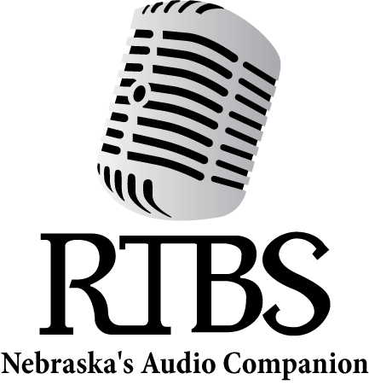

RTBS Board Members RTBS Staff

Ralph Morocco, President Michael Pflueger, Vice President Kyle Soares, Treasurer
Richard Harrington, Secretary Robert Burns
Christopher Connor, OD Pastor Peggy Hall Naomi Marion
John Miller Mark Nasser
Stephen Papenfuss, MD
Bekah Jerde, Executive Director
Ryan Osentowski, Program Director
Cami Cavanaugh Rawlings Communications Director
Michael Halula, Board Operator

