THE BROADCASTER
R A D I O T A L K I N G B O O K S E R V I C E

APRIL 2023 NEWSLETTER │ 2022 ANNUAL REPORT

RTBS Announces New Service in 2023!
Audio Description: Ensuring Accessibility

Radio Talking Book Service is thrilled to announce the addition of our newest service, Audio Description! From Broadway to ballet, RTBS partners with community venues to provide equal access to programming and events through audio description services.
This service empowers attendees with a visual disability to join family and friends for an exhibit, performance, or event. Then, using a headset provided by RTBS, they listen to a trained audio describer relate the visual information in real time. This can include costumes and sets, artwork, the antics of a team’s mascot, animals in a zoo habitat, the spectacle of a parade, Christmas lights twinkling in the night, and so much more!
Audio Description makes arts and culture accessible for everyone. Imagine Cinderella dropping her slipper, a priceless ancient artifact, or the winning goal, all of these examples are visual moments. We work to make these moments available for everyone. The audio describer uses breaks in action to narrate the visual material for the attendee with a visual disability. This ensures that everyone can attend an event together and everyone can understand the action.
RTBS is currently partnering with the Rose Theater and the Orpheum Theater to provide AD. Find upcoming described performances on our website, www.rtbs.org. Additionally, you can contact RTBS to request the service at a performance, event, outing, or venue not listed or if you have any questions at all about AD.

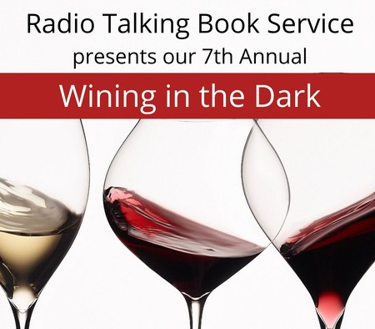MARK YOUR CALENDARS!!
Radio Talking Book Service is excited to announce we will be holding our 7th Annual Wining in the Dark at Nosh Wine Lounge! Test your taste buds with wines from around the world in a blindfolded tasting and delight in delectable delicacies created for your pleasure by the chef at Nosh Wine Lounge.

WHEN:
Sunday, April 23
4 to 6 p.m.
WHERE:
Nosh Wine Lounge 1006 Dodge Street, Omaha
Get your tickets today!
There will be a raffle including a night at the Omaha Symphony, original art by Bart Vargas, a signed Taylor Swift vinyl, two Film Streams packages, and more!
Seating is limited. Please purchase tickets by April 20 at rtbs.org or call 402-572-3003 to RSVP. Tickets are $75/person including gratuity, raffle entry, and a donation to RTBS.
Sponsorship opportunities available; contact Cami at 402-572-3003.

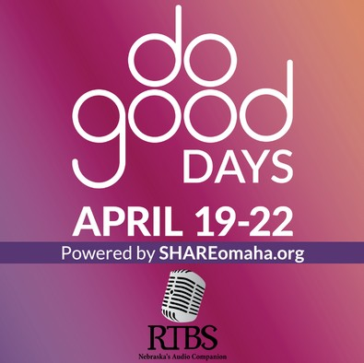
SAVE THE DATES!! DO GOOD DAYS ARE APRIL 19-22
Join in SHARE Do Good Days, April 19-22. These 4 days are focused on all forms of support for local causes and we can’t wait to see what the Omaha metro can do when we give together for more than one day!

Team RTBS will keep you posted about how you can bring the printed word to life during Do Good Days! There will be matching funds available during Do Good Days to make your donations go twice as far! Do Good Days makes it easy to support us with your dollars – and more!

Visit shareomaha.org/nonprofit/radio- talking-book-service-inc to learn more!

APRIL VOLUNTEER SPOTLIGHT:
VOLUNTEER SPOTLIGHTS
M A R C H 2 0 2 3 :
R O N S U P R E N A N T
F E B R U A R Y 2 0 2 3 : D E B A D Y
J A N U A R Y 2 0 2 3 : B O B B R O W N
D E C E M B E R 2 0 2 2 : S U E M O U T T E T
N O V E M B E R 2 0 2 2 : J O H N B O W E N
O C T O B E R 2 0 2 2 : D I A N E J O H N S O N
S E P T E M B E R 2 0 2 2 : M A T T H E W L E A F
A U G U S T 2 0 2 2 : J E A N E N G L I S H
J U L Y 2 0 2 2 :
J E F F G R I N N E L L
J U N E 2 0 2 2 :
M A R I L E E K E L L Y
M A Y 2 0 2 2 :
M I C H A E L F O U T C H
KAREN COTÉ
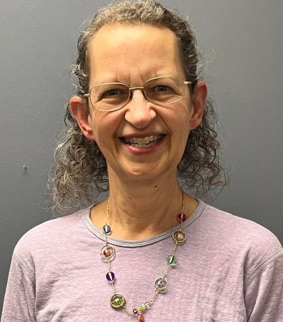
Karen Coté likes to say, “I’m not from anywhere.” She was born in Virginia, but life as a kid in an Army family proved to be a nomadic existence.
Her family finally put down roots in Memphis when she was a teenager, then she attended college in Tulsa.
She then took a job in the
restaurant industry, which brought her to Omaha, where she has lived for the last 43 years. She met her future husband while working at Jack and Mary’s. They have a son, a grandcat and two rescue pets.
After paying her dues working as a lettuce chopper in several restaurants, Karen spent most of her professional life working as a food purchaser for the Marriott Regency hotel. She retired five years ago and has filled her time volunteering at RTBS and the Humane Society. She is active at Dundee Presbyterian, enjoys gardening and looming hats.
She had a connection to RTBS long before she came to us as her brother-in-law’s mother, Joanne Boyer, was a volunteer coordinator at one time and she always encouraged Karen to donate a portion of her time and talent to reading for us. Karen finally followed through four years ago and has been a solid voice for us ever since. Karen is a woman of deep faith, a fact that is easily discernable whenever you hear her read from Guideposts Magazine. Catch Karen every Sunday afternoon at 1PM, with repeats at 1AM, on RTBS.
IN MEMORY OF:
DEANN BRIGHT CAROLE 'ANN' BOICE LARRY SEYL GLENDORA WEILAND NAOMI MARION

BY-RYAN OSENTOWSKI, PROGRAM DIRECTOR

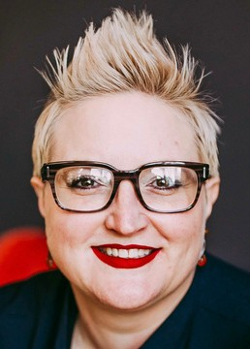
BEKAH JERDE EXECUTIVE DIRECTOR

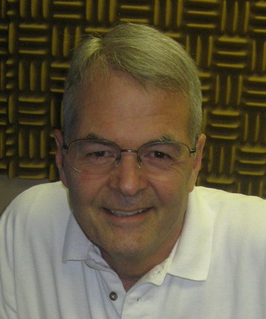
RALPH MOROCCO BOARD CHAIR
2022 was an amazing year at RTBS! We added lots of local programming in 2022: Mind Your Business, Nebraska Virtual Newsstand, Southeast Nebraska Newspapers, and the Sioux City Journal, increasing our regional newspapers offerings from 12 to 17. We have refreshed our Bookshelf program to focus on fiction and nonfiction books written by Nebraska authors.
Moving forward, RTBS will utilize a hybrid of in-person and remote readers to provide the vital, local programming our listeners rely on. This led to a decision to decrease our square footage. In July 2022, we reduced our physical space and rent payment by approximately forty-five percent.
DIRECTOR'S CORNER
RTBS is thrilled to announce the addition of a new service in 2023, Audio Description (AD). From Broadway to ballet, RTBS partners with community venues to provide live audio description for performances and community events. Audio Description makes arts and culture available for everyone.
I cannot begin to express my gratitude and admiration of our dedicated, resilient staff, volunteers, and board for ensuring our listeners access to RTBS programming. For all the ways YOU support RTBS, thank you!

A NOTE FROM THE CHAIRMAN
Radio Talking Book has just completed its first full year under the energetic leadership of Bekah Jerde. It has been a year of growth in our listening audience, reduction in the size of our office, and the addition of our new audio description service.
To prepare for whatever is next, the entire staff and some Board members will be engaged for a day of strategic planning in April, facilitated by RTBS board member Melissa Smith. This effort will be designed to position RTBS to better serve our growing audience, prepare us for technology changes that may affect how listeners access our services, and help us deal with the challenges faced by small non-profit organizations.
As Board chair, I want to thank our volunteers, including board members who help guide the organization, and those whose voices, talent and commitment of time, bring our programming to life. I would also like to thank our donors – the Omaha Association of the Blind, the foundations, individuals, and listeners – who have helped us to meet the needs of those who count on us for the news and information that is so critically important. Finally, I would like to thank our small staff, Bekah, Ryan, Cami and Michael, who are working each day to keep our services available for listeners.

DONATIONS: April 2022-March 2023

CORPORATE/FOUNDATIONS

The Adah and Leon Millard Foundation Alan & Marcia Baer Foundation
Bank of the West Blackman & Associates PC Boomer Radio
Bridges Investment Management Community Foundation for Western Iowa Dixon Family Foundation
Edward & Lida Robinson Charitable Trust Ethel S. Abbott Charitable Foundation Farm Credit Services
Gilbert M. & Martha H. Hitchcock Foundation The Hawks Foundation
Ike & Roz Friedman Foundation Immanuel Vision Foundation JK Barker Foundation
Kroger / Dillon Stores The Lozier Foundation
Manota E. Simon Foundation Marilyn N. Scott Trust
Marshall & Mary Brondum Special Assistance Foundation The Max & Victoria Dreyfus Foundation
The Milton S. & Corinne N. Livingston Foundation Oliver & Ferrol Barklage Foundation
Omaha Performing Arts Omaha Theater Company Pettit's Bakery
Retina Center of Nebraska Robert Herman Storz Foundation Robin Hill Fund
Rupert Dunklau Foundation The Sherwood Foundation The Steinhart Foundation Thrivent Financial Walgreens
Webster Family Foundation William R. Patrick Foundation

WINING IN THE DARK 2022 SPONSORS
Paula Dietering, Prairie Wealth Advisors Golden Years Senior Relocation LLC Security National Bank
Outlook Nebraska Bonnie Jerde
The Brant Senior Living: Gretna Identity Marketing
Matt Jetter, Medicare Insurance Solutions EmSpace + Lovgren
Rahl Foundation Michael Pflueger Bartekah, LLC

ORGANIZATIONS/COMMUNITY GROUPS

Aurora Lions Club Battle Creek Lions Club Clay Center Lions Club
Columbus Noon Lions Club Cook Lions Club
Crete Lions Club Gordon Lions Club
John C. Fremont Lions Club Neligh Lions Club
Ogallala Lions Club
Omaha Westside Lions Club Papillion Area Lions Club PEO Sisterhood Chapter EC Pierce Lions Club
Presbyterian Women in the Congregation Scottsbluff-Gering Lions Club
St James United Methodist Women Tekamah Lions Club
The Original Bookies Wallace Lions Club

UNDERWRITING

CCA Home Care Hillcrest Heath Systems Outlook Enrichment Senior Blue Book

INDIVIDUALS
Jamie Abernathy Caralee Adams Deb Ady
JoAnn & Fred Aliano, Sr Melanie Anania
Jon Anderson Marcia Anderson Nancy Anderson Anonymous Howard Bachman Kim Balkovec Melissa Barnett Mary Barnhart Brian Bartels
Paul Bartels Bob Bastarache Cindy Bedford Susan Beeghly Kaye Bellino
Nolan & Lorene Berry Sandra Bianchi Scott & Sharon Bird Melodee Bock

INDIVIDUALS INDIVIDUALS INDIVIDUALS INDIVIDUALS

Patty Bogatz Kate Bolay
Joni & Bill Bollinger Mikell Bowsman Frank Brannon
Pat Brennan DeAnn Bright Janice Bright
Grant & Barbara Brollier Judy Brooks
Bob Brown
Lawrence & Joan Friend Christina Frost
John & Elizabeth Fullerton Robert & Nan Fullerton Scott & Tricia Fullerton Beth Furlong
Peter Gadzinski Tom Garvey Bob Goding Polly Goecke
Doris Goembel
Rebecca Armstrong Langle Sharon Larson
Cynthia & Philip Lee Raymond LeFaivre Mary Jane Leistra Wendy Leitch
Ed Leslie Lenora Levin Beverly Lydick Gina L. Mack
Kenneth Mahaffey
Jane Onken-Roberts & Jim Roberts
Paul Orwig Caitlin Osborn
Rich & Karen Osentowski Ryan Osentowski Dolores Ostrom Maureen Panzer
Cathy Ann Pasko Lyle Paul
Caroline Pennington

John & Rosemary Brownrigg Katherine Graham
Gina Maloley
Larry Peterson

Greg & Sue Bruening Mark Bulger
Robert Burns Kym Bybee
Nick & Evelyn Calava Jim Carlson
Bill and Sarah Carver Rachel Carver Dianna Cato
Cami & Shell Cavanaugh Rawlings
Dr. John Chedester Jill Chleborad
Norman and Phyllis Choat Michael Clauson
Pamula Clifford Nancy Coffman Christopher Cold Laura Cooper David Corbin Karen Coté
Kim E Crayne Alistair Cullum Mark Davis Paula Deitering
Melinda Dominguez Marie Dougherty Marina Drake Lucille Dunlavy Aaron Duspiva
Lori Ecklebe Gary Emenitove Mary Ensz
Joe Ernst Margaret Fegler Amy & Todd Feltz Mark Fidone Nancy Flearl George Flock Sarah Fratt
Sol & Lois Friedman
Christian Gray
Patrick & Jocelynn Gray Sherri Green
Donna Grimm Jeffery Grinnell Rachel Grossman Richard Gulizia Terry & Judy Haney Teresa Hansen
Lee Harlan
Dick Harrington Linda Hatfield Amy Hatter Cheryl Hazel Phyllis Heimann Lakelyn Hogan Helen Hohndorf Lindsey Holley Nancy Holloran Kathy Hoyt
David Huelsmann Kim Huff
Sharon Ishii-Jordan Margaret Janssen
Bekah Jerde & Bart Vargas Bonnie K. Jerde
Judy Johnson Donn Jones
Kim Jubenville Carlson Susan Kelley
Lori Kesinger John Kieran Vickey Kleinsmith Nick Klissiaris Tara Knapp
Barb Knapper Marj Krawczyk
Jack & Marie Kubat Barbara Kuhn Howard Kutler David Laferla
Yano & Cindy Mangiameli Joe Marino
Randell Martin Amy Mather
Bob & Terri Mathews Rhonda Matney Julie McCarty
Tom McCaugherty Lynn McCormack Janet McCrae Catherine McGowan Melissa McMullen Loretta McNally
Linda & Thomas A. Mertz John Miller
Mark & Carolyn Miller Rick & Jane Miner Steve Minor
Ron Mohler Bev Mohr
Paulette & Phil Monthei Ralph Morocco
Jo and Steve Morton Judy Moslander
Sue Mouttet Karen Murphy Paul Murphy Kathy Mussack Nadine Nadrchal Bill Naidenovich Mark Nasser Barbara Naughtin Jane Nielsen
Diane & Joe Nietfeldt Jessica Nitsch Patrick Noonan Becca Norrie
Janet Nuss RE Nystrom
Kristen Oertell Kathleen Ogden
Michael Pflueger John Phillips
Jon and Dorothy Polan Mike Prenger
Judy Price
Carol Ravnsborg Shiela Rawlings Melissa Ray
Daniel & Annie Rezac Carol D. Reznicek Mary Reznicek
Marty Riemenschneider Jo Roberts
John Rogers Laura Romito Carol Sanderhoff Kelle Scott
Larry & Judy Seger Tanya Shaul
Tom & Sue Sheeren John Shepherd
Paul & MaryLou Sherrerd Curt Siemers
Mike & Stephanie Sigmond
Susan Slominski-Caster Melissa Whittle Smith Darvin & MeMe Smith Kyle Soares
Willard Spech
Karen & Kevin Staley Karen Stander
Laura Steffes Rick Stone
Maureen & Matt Strain Chris & Barb Stratman James Surber
David Sutherland Robert Swanda Jr Jeanne Swartz Barbara Switzer Mary Talen
Mike Taylor

INDIVIDUALS
Anita Theophilus Sheryl Thomas Catherine L Tierney Linda Todd
Ralph Tosti Kaye Travnicek Deb Trivitt
Jaimee Trobough Erin Van Zee
Bart Vargas
Terry & Patti Veylupek Tom & Bev Vitamvas Lois & Harris Voss
Vic Wagner Marialyce Walsh Sarah Watson Steve Wehrbein Misty West
Jean Wheatcraft Jason Whitney David Wiesman Sally Wilhelm Steven Willoughby Fran Witt
Dolores Wolsleben Jenny Wulff
John & Sara Young Margaret Youngberg

GIFTS IN HONOR OF
Dr. Prema Abraham Ada & Mamie
All Military Vets Gale Bowers
Cami Cavanaugh Rawlings Lucille Dunlavy
Friedman Children

GIFTS IN HONOR OF
John & Elizabeth Fullerton Michael Halula Bekah Jerde
Ed Leslie Jack Martin Janet McCrae
Ralph Morocco Ryan Osentowski Mona Jean Roberts RTBS Staff Veylupek Family

GIFTS IN MEMORY OF
Jim Acuff Fred Aliano, Jr
Audrey Wright Anderson & George C. Anderson
Gloria & Kenneth Armstrong Christine Ann Bachman Dave Bandi
Robert Bianchi Ina Bock
Sarah Bogatz Ann Boice Opal Bosn DeAnn Bright Frank Calava Dorothy Carter
Jefford & Pat Cold
Craig & Marian Fullerton Josephine Curro
Ann Davis
Betty Dougherty Bernice & Isadore Falk Anne Foley
Shirley Goodro

GIFTS IN MEMORY OF
Millie Hansen
Wanda & Myron Harris Mary Eva Henney Betty Hohndorf
Jack & Sheila Brownrigg Dean Janssen
Trudia Jones Elizabeth Kiewit James F. Krier Urdine Lancaster Martha LeFaivre
Leighton & Marietta Lee Robert Dean Major Naomi Marion
Elaine McCrae & Andrea Otness Trudy Miller
Betty Minor
Debbie Misenhetler Jan Moritz
Ethel & Milford Murphy Jane Peterson
LaVon & Kay Peterson Leona Nadrchal
Joan J Paul Bill Pfeiffer
Gwen Rasmussen Mary Rook
Ruth Sage Robin Tosti Alice Wagoner
Mickie I. Waldron Tom Walsh Glendora Weiland Bud Wheatcraft Georgia Wheeler Ron Witt
Dick Zlab

Radio Talking Book Service thanks everyone for their generous support!!

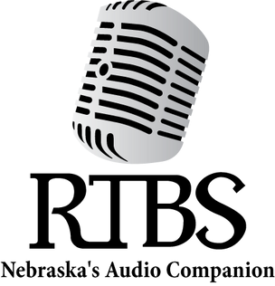

RTBS Board Members RTBS Staff

Ralph Morocco, President Michael Pflueger, Vice President Kyle Soares, Treasurer
Richard Harrington, Secretary Robert Burns
Rachel Carver Christopher Connor, OD John Miller
Stephen Papenfuss, MD Melissa Smith
Bekah Jerde, Executive Director
Ryan Osentowski, Program Director
Cami Cavanaugh Rawlings Communications Director
Michael Halula, Board Operator

