THE BROADCASTER
R A D I O T A L K I N G B O O K S E R V I C E

APRIL 2021 NEWS L ET T ER │ 2020 ANNUAL REPORT

The Show Goes On!

One year ago, the Radio Talking Book Service made the difficult decision to close our doors and send our volunteers home due to the encroaching pandemic. Yet, the staff was adamant that our listeners should not be deprived of the news and information that was so critical to them during these perilous times. And so, the show did go on. Thanks to modern technology, we were able to bring the familiar voices of our readers into the homes of our listeners without interruption through remote recordings.

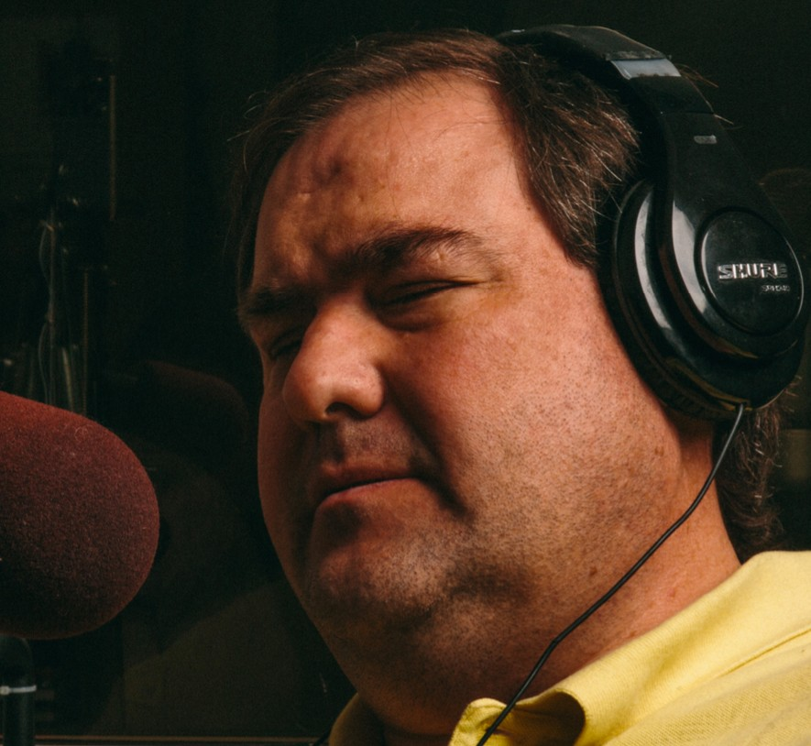

BY
RYAN OSENTOWSKI STATION MANAGER

Every few weeks, the staff would discuss when and how we would reopen. Would it be mid-May, early June or late August? As the months rolled on and the COVID numbers mounted, we realized that, like most Americans, our work- from-home routine would be more long term than we had first hoped.

Now, a year later with three vaccines in circulation, we are finally solidifying our plans for a long-awaited reopening. Details are still evolving, and we are mindful of the caveat that this developing plan will only reach fruition if the situation continues to improve. But we cannot ignore the dawn of hope that is finally breaking to end this long, dark night of human isolation.

Through all of the anxiety, uncertainty and delays, our volunteers have remained constant, reliable, and firm in their resolve to help bring the printed word to our listeners. Thank you all for the past year. We love you and we can’t wait to see you again.

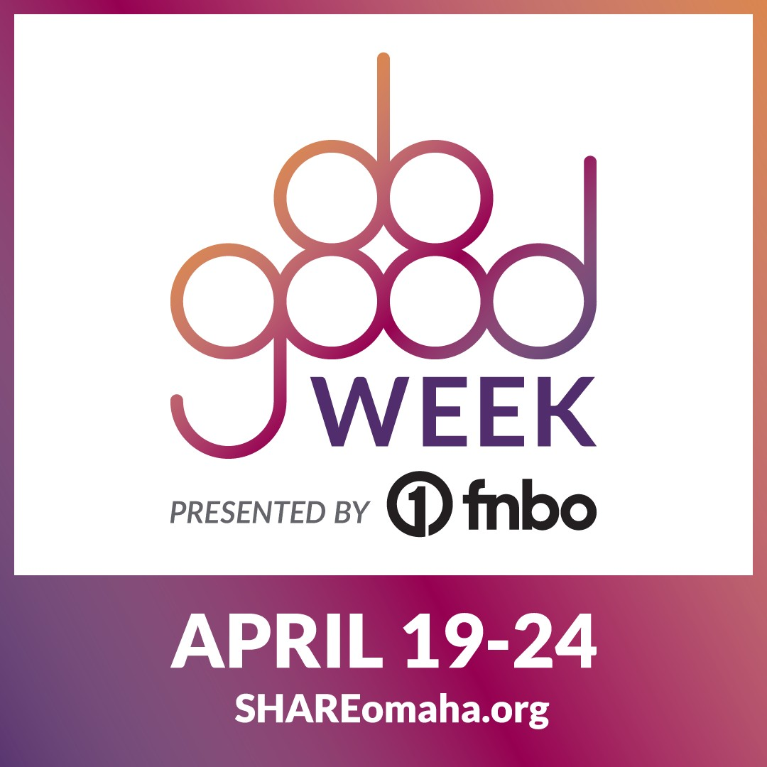MARK YOUR CALENDARS!!

- April 19: Mission Monday
Learn more about our work!
- April 20: New Donor Tuesday
If you’ve never given a gift to our organization, now’s the time!
Your gift could help us unlock a cash prize. (Plus, matching funds will double your gift!)
- April 21: Wish List Wednesday
Buy items from our wish list to support our work
  - April 22: Volun-Thursday
Join our volunteer team
    - April 23: Fund It Friday
Help us meet our $5,000 goal! Your donation goes twice as far with matching funds!
- April 24: Celebration Saturday
Time to celebrate your generosity! Cheer for us as we hope to a win cash prize!

DO GOOD WEEK is April 19-24!!
Last year, 2020, marked the end of Omaha Gives – thank you for your past support!
Mark your calendars for a new way to support our needs. Join in SHARE Omaha’s Do Good Week, April 19-24, presented by FNBO. This week is focused on all forms of support for local causes and we can’t wait to see what the Omaha metro can do when we give together for more than one day. Do Good Week makes it easy to support us with your dollars – and more!
OVER $7,500 in MATCHING FUNDS!!
Team RTBS is super excited to announce that we will have over $7,500 in matching funds available during Do Good Week to make your donations go twice as far! Mark your calendars & join us April 19-24! Team RTBS will keep you posted about how you can bring the printed word to life during Do Good Week! A big thank you to our dedicated RTBS Board of Directors for their generosity in providing this match!
Visit shareomaha.org/nonprofit/radio- talking-book-service-inc to learn more!

NEW PODCASTS AVAILABLE!
Tech It Out! Nebraska Life Huskerholics
rtbs.org

APRIL VOLUNTEER SPOTLIGHT:

N
DICK HARRINGTO

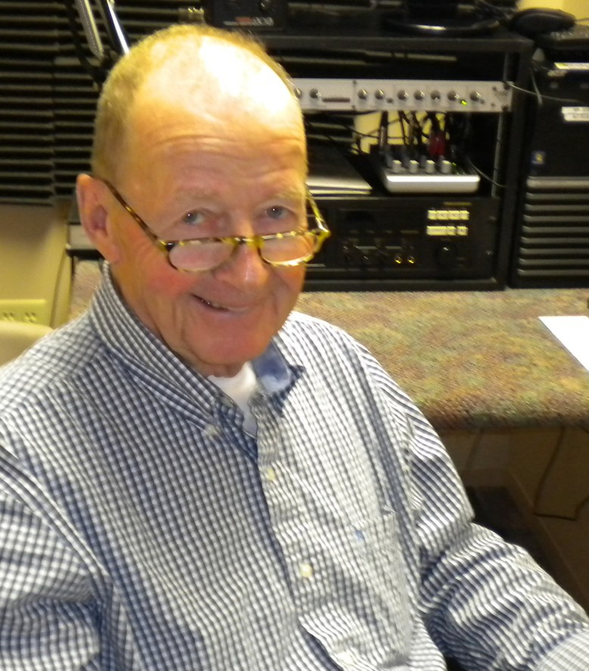
If you listen closely, you might hear a hint of a Boston accent because Dick Harrington and his three brothers were raised in that area. However, he has traveled the world enough that little of it remains. Dick enjoyed a 26 year career in the Air Force that took him to many states and overseas to Denmark, Spain, and Vietnam.

He followed that by working for FEMA for 14 years.
RICHARD "DICK" HARRINGTON
2020 STEP FORWARD VETERAN VOLUNTEER OF THE YEAR

In 2000 Dick retired and began his “careers” in volunteering. He began volunteering for RTBS in March of 2010 and has been the weekly reader/recorder of the Norfolk Daily News. Dick has been serving on the Board of Directors since April of 2014 and took on the Secretary responsibility almost from day one on the Board. He has also represented RTBS at community events including the CHI Health Fair and the Vision Resource Fair. Dick has also conducted special interviews with veterans used as part of special holiday programming. Dick has provided the introduction for our weekly Veterans Hour program including his personal contact information for those needing VA services for the blind, as well as any veteran service. Dick has been a volunteer at the Omaha VA hospital for 11 years. Dick helped form the Final Salute Society, to give deceased veterans with no known family a proper farewell at the Omaha National Cemetery.
VOLUNTEER SPOTLIGHTS
M A R C H 2 0 2 1 : D A V E R A D L I F F

F E B R U A R Y 2 0 2 1 : L A U R A C O O P E R

J A N U A R Y 2 0 2 1 : D O N V A N
M O O R L E G H E M

D E C E M B E R 2 0 2 0 : A N I T A T H E O P H I L U S

N O V E M B E R 2 0 2 0 : D I C K H A R R I N G T O N

O C T O B E R 2 0 2 0 : S U E B E E G H L Y

S E P T E M B E R 2 0 2 0 : F R A N K H E R Z O G

A U G U S T 2 0 2 0 : R I T A K U E N N I N G

J U L Y 2 0 2 0 :
B R A D S C H R O E D E R

J U N E 2 0 2 0 :
L A U R E N B A R T E L S

M A Y 2 0 2 0 :
J I M C A R L S O N
Dick was honored as the 2020 ServeNebraska Step Forward Veteran Volunteer of the Year. He was chosen by the Governor for this prestigious award for his dedication to services that impact people throughout the state. RTBS is lucky to have you as part of our volunteer team!

BY-MEME SMITH, VOLUNTEER COORDINATOR

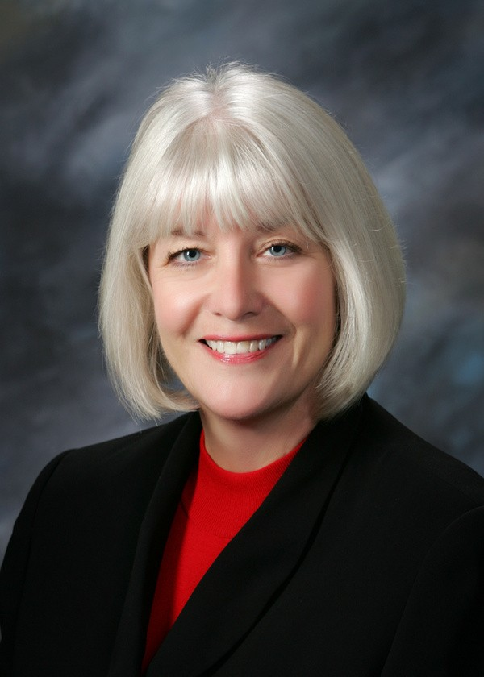
JANE NIELSEN EXECUTIVE DIRECTOR

RALPH MOROCCO BOARD CHAIR

DIRECTOR'S CORNER

I am so impressed by and proud of Team RTBS! Bekah, Ryan, MeMe, and Michael responded to the COVID-19 crisis a year ago by transforming our dedicated volunteers into remote readers. We have over 60 volunteers reading newspapers, grocery and department store ads, and more, seven-days-a-week from their homes. We were able to maintain our 24/7 programming with no interruption and little change. We produced programming to directly address the needs for our listeners concerning COVID including a weekly program highlighting food delivery options, access to streaming Easter services, and a special edition of the Community Calendar that focuses on mail-in ballots and other election information. The Team modified our weekly, statewide Community Calendar to share closures and cancellations due to the virus. And now we are sharing re-openings; food assistance; medical assistance; and daily COVID updates with resources, contact information, and recently, vaccine information for our listeners.
Finally, the RTBS Team is hard at work on a plan to safely reopen the studios and office to our wonderful volunteers as early as June.
Thanks Team!

A NOTE FROM THE CHAIRMAN
A year has passed since the WHO declared a pandemic. What incredible changes we’ve all experienced. Changes have been required everywhere. How we shop, how we interact in person, whether we can see sons or daughters, parents or siblings, how we celebrate the joys and acknowledge the tragedies in life, are all much different today than they were just one year ago. RTBS has adjusted as well. Volunteers no longer read in our studios but have stepped up to bring the gift of their voices for our regular programming from their homes. Board meetings have been held by conference call or zoom. Our dedicated staff team has worked from both home and our office to keep our listener’s radios and web streaming services working and our website fresh.
As Board chair, I want to thank the volunteers who have adjusted to new technologies and new ways of doing things so that we could keep our commitment to deliver the news and information our listeners depend upon, while keeping staff and volunteers safe. I would also like to thank the donors – associations, foundations, individuals and listeners – who have helped us continue to meet the needs of our listeners for the news and information that is so critically important in these difficult times. We hope much better days lie ahead.

DONATIONS: April 2020-March 2021

CORPORATE/FOUNDATIONS

Back 2 Health Bank of the West
Cari Sommer Charitable Fund Dixon Family Foundation
Edward & Lida Robinson Charitable Trust Ethel S. Abbott Charitable Foundation Farm Credit Services of America
Gilbert M. and Martha H. Hitchcock Foundation Grant Dental Plaza
Hawks Foundation
Home Instead Senior Care Foundation Ike & Roz Friedman Foundation Immanuel Vision Foundation
JK Barker Foundation Kroger Stores
Manota E. Simon Foundation
Marshall & Mary Brondum Special Assistance Foundation The Max and Victoria Dreyfus Foundation
Midlands Community Foundation
Milton S. & Corinne N. Livingston Foundation Oliver & Ferrol Barklage Foundation Trust Retina Center of Nebraska, P.C.
Robert Herman Storz Foundation Rupert Dunklau Foundation
Sarpy County Chamber of Commerce Foundation Sherwood Foundation
Seda Family Foundation TD Ameritrade Steinhart Foundation
University of Nebraska-Omaha Webster Family Foundation William R. Patrick Foundation

WINING IN THE DARK 2020 SPONSORS

Security National Bank
Paula Dietering, Prairie Wealth Advisors Outlook Nebraska
Bonnie Jerde
Bland Cares Foundation Bank of the West
Matt Jetter, Medicare Insurance Solutions Immanuel Communities
Identity Marketing Group
Golden Years Senior Relocation Experts Oh-K Fast Print

ORGANIZATIONS/COMMUNITY GROUPS

Battle Creek Lions Club Crete Lions Club
Hastings Evening Lions Club Hildreth Lions Club
Neligh Lions Club Ogallala Lions Club
Omaha Association of the Blind Papillion Area Lions Club Patient Care Counsel
Pierce Lions Club Tekamah Lions Club

UNDERWRITING
Enable Savings Plan Hillcrest Heath Systems Outlook Enrichment Senior Blue Book

INDIVIDUALS
Dorothy Abbott Cathie Adams Donna Aman Jon Anderson Nancy Anderson Anonymous
Howard Bachman Kim Balkovec Elizabeth Banset Kenneth Barjenbruch Melissa Barnett
Laura Beth Barr Dolores Barraclough Bob Bastarache
Michael & Linda Bechtel Patti Bendgen
Helen Benner Fran & Jack Berg Sandra Bianchi
Brian & Sarah Birkby Tom & Pat Blasing Patty Bogatz Wendell Bogle
Ann Boice
Joni & Bill Bollinger Ayanna Boykins Pat Brennan

INDIVIDUALS INDIVIDUALS INDIVIDUALS INDIVIDUALS

Pat Brennan Patrecia Brodersen Judy Brooks
Bob Brown
Rosemary & John Brownrigg Patricia Buckmaster
Ray Buell
John & Nancy Burch Sue Burger
Daniel & Sharon Burns Gerald Bushnell
Jean Butler
Connie Butterworth Nick & Evelyn Calava Jim Carlson
Kim Jubenville Carlson Mary Carlson
Karol Carroll Elaine Chapin Mary Chase John Chedester Jill Chleborad
Phyllis & Norman Choat
L.A. & Carolyn Christensen Nancy Christensen
Joan Clark Imogene Clements Pamula Clifford Nancy Coffman Christopher Cold Michael Combs Laura Cooper Patricia Cornett Karen Cote
Kim E Crayne Alistair Cullum
Charlotte & Roger Curry Nancy Davenport Richard & Melba Dean Lois Lynn Denzler
Jodie & Jim DeSordi Diane Diffey
Nancy Dirks Tami Doll
Marie Dougherty Mary Douglas Steve Douglas Marina Drake
Harlan & Teri Dreessen Wayne & Sheila Dreessen Lucille Dunlavy
Lori Ecklebe Gary Emenitove
Joe Ernst Bill Everhart
Amy & Todd Feltz Nancy Flearl George Flock Peggy Flynn Christina Frost Jack Frost
Jim Fullerton John Fullerton Robert Fullerton
Peter & Mary Gadzinski Mike & Ellen Gaherty Ruth Garrison
Pat Geary Cynthia Gibbs
Steve & Peg Gibbs Bonnie Gill Joanne Gilmore Bob Goding
Sue Goding Polly Goecke Jan Gorman
Katherine Graham Jeanne Gray
Patrick & Jocelynn Gray Sherri Green
Helen Griffith Jeffery Grinnell Carol Grote Anne & John Hall Peggy Hall Wendy Hamilton
Michael & Britt Hanson Lee Harlan
Dick Harrington Michaela Hart Elizabeth Harvey Cheryl Hazel Edith Hecht Brenda Hennigs Iris Herse
Frank Herzog Monica Hickman Don Hieb
Patti & Robert Hill Walt Hively Catherine Hohman Helen Hohndorf Lindsey Holley Nancy Holloran Marise Hopkins Donna Houghton
Kathy Hoyt Tara Hudson
David Huelsmann Mabel Huff Harlan Jacobson Marvin J Jedlicka Tom Jensen Bonnie K. Jerde
Bekah Jerde & Bart Vargas Matt Jetter
Alan Johnson
Kendra & Chuck Karbowski Keegan Korf
Hedwig Kelley Susan Kelley Marilee Kelly John Kieran Vickey Kleinsmith Barb Kokrda
Marj Krawczyk Jayne Krier Eunice Krohn
Jack & Marie Kubat Barbara Kuhn
Daniel & Colleen Kurmel Celia LaGreca
Marty LaLande Hans Langner Sharon Larson
Barb & Rand Lauritzen George Lavoie
Brian Leichner Nancy Lepo Edmund Leslie Lenora Levin Ric Lutz
Kenneth Mahaffey Jackie Mahr
Dr. Edward Malashock Bill Manning
Mark and Heather Shelton Debra L Marshall
Bonnie & Ted Martin Randell Martin
Amy Mather
Bob & Terri Mathews Rhonda Matney Patrick & Mary McBride Julie McCarty
Lynn McCormack Robert McCoy Janet McCrae
Catherine McGowan
Raedeen McGowan Lisa McIntosh
Kristi McKamy
Dennis & Debra McMillan Melissa McMullen
Irene Meaker
Celeste & Frank Mech Peggy Menck
Linda & Thomas Mertz Barbara Metz
Mark & Carolyn Miller Weenonah Miller Rick Miner
Jim Minovsky Stephanie Miske
Richard & Helen Mitchell Ron Mohler
Ralph Morocco Karen Morris
Jo & Steve Morton Megan Moslander Sue Mouttet Marleen Muenster Paul Murphy Kathy Mussack Mark Nasser Barbara Naughtin
Jody Neathery-Castro Dean Nicholson
Jane & Dean Nielsen Jessica Nitsch
Mary Noonan John Nownes Neal Obermeyer
Jane Onken & Jim Roberts Caitlin Osborn
Rich & Karen Osentowski Ryan Osentowski Dolores Ostrom
Dr. Stephen Papenfuss Kelley Patton
Nancy Pawloski Connie & Doug Pera Patty Perry
Dale & Constance Petersen John Phillips
Laura Pierce
Jon & Dorothy Polan Mary Ellen Pospishil Sandra & Cedric Prange Vicki Pratt
Jean Prendergast Judy Price

INDIVIDUALS INDIVIDUALS GIFTS IN HONOR OF GIFTS IN MEMORY OF

Carol Ravnsborg Melissa Ray John A Rebrovic Joyce Renner Marilyn Repshire
Daniel & Annie Rezac Mary Reznicek
Marty Riemenschneider Beth Reilly
Marvin & Gloria Rinkol Darlene Rischling Todd Robinson
Karen Roenfeld John Rogers Laura Romito Linda Rookstool
Lauren & Philipp Ruhe Joann Sawyer Michelle Schrage Alice Schuler
Sharon Schweitzer Kelle Scott
Larry & Judy Seger Louis Seybold Tom Sheeren Kathy Shelsta
Heather & Mike Shelton John Shepherd MD
Paul & MaryLou Sherrerd Mary Shipp
John Shoemaker Curt Siemers Jaymes Sime Jean Sitter MeMe Smith Kyle Soares Gloria Sorenson
Melinda Sorenson Will & Janice Spech Karen Stander Sharon Stanich Sue Stark
John & Georgia Stevens
Linda & Phil Stone Rick Stone
Maureen & Matt Strain Chris & Barb Stratman James Surber
David Sutherland Josh Tague
Mary Talen Terry Theis
Anita Theophilus Sheryl Thomas Catherine L Tierney Ann Tjaden
Linda Todd
Ralph & Charlotte Tosti Kaye Travnicek
Deb Trivitt
Donna & Terry Turner Don Van Moorleghem Erin Van Zee
Bart Vargas Terry Veylupek Lois Voss Trilety Wade Tom Walsh
Madeline E. Ward Sarah Watson Steve Wehrbein Leslie Wells Sarah Wengert Jean Wheatcraft Susan Whitfield Jason Whitney David Wiesman Shawn Wilbur
Kathleen Williams Steven Willoughby Frank Winters Matt & Annie Wise Fran Witt
Dolores Wolsleben Jenny Wulff
John & Sara Young
Dr Abraham & the staff at Rapid City Eye Institute
Deb Ady
Red & Esther Bechtel Lucille Dunlavy Elijah
First responders to COVID-19 pandemic
John Fullerton
Mike & Ellen Gaherty Shelly Gray
Michael Halula Bekah Jerde Janet McCrae Ralph Morocco Dean Nielsen, Jr Jane Nielsen
Ron (RE) Nystrom Ryan Osentowski Our grandchildren-
John, Mary Grace, Julia, Liz, Isam, Emily, & Ryan
Bill Rasmussen Mona Jean Roberts MeMe Smith Willard Spech Wyatt
The Fabulous RTBS Staff The great people & orgs that
help me with my vision loss!

GIFTS IN MEMORY OF
George "Andy" Anderson & Audrey Wright Anderson Lola Baker my grandmother Ray Barr
J Clarice "Dee" Bartek Ednamae Beaty Sarah Bogatz
Jack & Sheila Brownrigg William Buckmaster Frank Calava
Kenneth Carlson Bob Casper
Jefford & Patricia Cold Eloise Craft
Josephine Curro Lyle Doll
Joseph & Mildred Fanciullo Craig & Marian Fullerton John "Jack" Gibbs
Carol N. Griffith Mildred "Millie" Hansen Mary Eva Henney
Betty Hohndorf William P. Houston Scott Hoyt
Eileen Jacobson Fr Don Kirchner Jean Knowles
Dr James F. Krier Urdine Lancaster Sally Malashock Robert L. Manning Dorothy McMillan
Elaine McCrae & Andrea Otness Glenn Miller
Trudy Miller, my mother Jan Moritz
Norma & Bob Mountain John Muenster
Ethel & Milford Murphy Marjory Papenfuss Joan J. Paul
Tim Pawloski Ann Pelikan
Alice Finley Sullivan Perry Alice Jane Peterson LaVon & Kay Peterson
Bill Pfeiffer
Gwen Rasmussen Ivan "Buz" Sawyer Donovan Schuler June Stanich mom Robin Tosti
Isabelle Trobough & Bernice Falk Ed & Darlene Veylupek
Alice Wagoner Georgia Wheeler Ron Witt
Jim Zavodny Dick Zlab

Radio Talking Book Service thanks everyone for their generous support!!

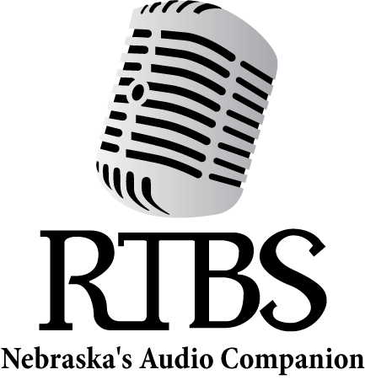

RTBS Board Members RTBS Staff

Ralph Morocco, President Bob Goding, Vice President Kyle Soares, Treasurer Richard Harrington, Secretary Robert Burns
Christopher Connor, OD Pastor Peggy Hall Naomi Marion
Mark Nasser
Stephen Papenfuss, MD Michael Pflueger
Jane Nielsen,
Executive Director Bekah Jerde,
Assistant Director Ryan Osentowski,
Station Manager MeMe Smith,
Volunteer Coordinator Michael Halula,
Board Operator

