THE BROADCASTER

**R A D I O T A L K I N G B O O K S E R V I C E**

APRIL 2025 NEWSLETTER │ 2024 ANNUAL REPORT

# Thank you for helping RTBS Celebrate 50 Years of Service!

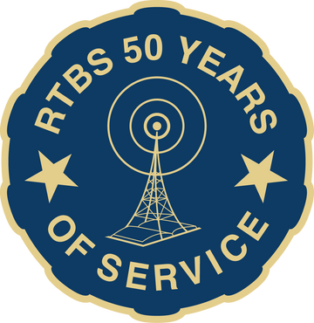As we reflect on 2024 and celebrating 50 remarkable years of service, we are bursting with gratitude for all who have been part of this journey! This milestone could not have been achieved without the tireless efforts of our dedicated staff, volunteers, and supporters. Whether you contributed your time, expertise, or resources, YOU have played a pivotal role in making this anniversary year one to remember.

To our volunteers, thank you for your compassion and commitment. Your voices, your time, and your unwavering support have made our broadcasts a trusted and essential resource. To our donors and partners, your generosity ensures that we can continue to offer these vital services to those who need them most. You helped us raise over

$70,000 in our $50K for 50 Years efforts! Together, we have not only reached this extraordinary anniversary but have also strengthened the foundation for another 50 years of service! Your belief in our mission has helped us grow, evolve, and expand our reach, bringing us closer to our vision of an accessible, inclusive world. Thank you!

# We Celebrated!

A HUGE THANK YOU to everyone who supported our 50 Years of Service Celebration on September 18th, 2024! It was an honor to share our history and look ahead to the future with so many familiar and new faces. Thanks to your generosity, we raised over $10,000 at the event!

A special thanks to John Fullerton, Richard Parker, and Jane Nielsen for sharing your memories and experiences. Shout out to Michael Halula for being a fantastic announcer, and to the entire RTBS team - Ryan, Cami, and Bekah - for their stories, hard work, and dedication.

**GET YOUR TICKETS TODAY!!**

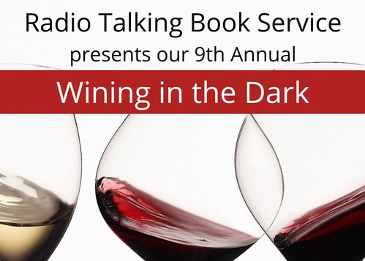

Radio Talking Book Service is excited to announce we will be holding our 9th Annual Wining in the Dark at Nosh Wine Lounge! Tickle your taste buds with wines from around the world and delight in delectable delicacies created for your pleasure by the chef at Nosh Wine Lounge.

WHEN:

Sunday, April 13

4 to 6 p.m.

WHERE:

Nosh Wine Lounge 1006 Dodge Street, Omaha

Get your tickets today!

There will be a raffle including Omaha Storm Chaser box seats, a Nebraska Bookshelf filled with signed copies, a golf outing, dinner at Dolomiti Pizza, and more!

Seating is limited. Please purchase tickets by April 11 at rtbs.org or call 402-572-3003 to RSVP. Tickets are $80/person including gratuity, raffle entry, and a donation to RTBS.

Sponsorship opportunities available; contact Bekah at 402-572-3003.

**SAVE THE DATES!! DO GOOD DAYS ARE APRIL 23-26**

## Join in SHARE Do Good Days, April 23-26!

These 4 days are focused on all forms of support for local causes, and we can’t wait to see what the Omaha metro can do when we give together for more than one day!

Team RTBS is excited for our **Community Read- a-Book-a-thon** during Do Good Days! We are inviting folks to pop in to read a chapter (or two!) of a Nebraska authored book with a goal to finish recording the book in three days to broadcast on-air for our listeners!

## Do Good Days makes it easy to support us with your dollars – and more!

Visit shareomaha.org/nonprofit/radio- talking-book-service-inc to learn more!

**APRIL VOLUNTEER SPOTLIGHT:**

**VOLUNTEER SPOTLIGHTS**

M A R C H 2 0 2 5 : L I Z K E R R I G A N

F E B R U A R Y 2 0 2 5 : J O E W A T S O N

J A N U A R Y 2 0 2 5 : D E B A D Y

D E C E M B E R 2 0 2 4 : D O N V A N

M O O R L E G H E M

N O V E M B E R 2 0 2 4 : R I T A K U E N N I N G

O C T O B E R 2 0 2 4 : B O B B A S T A R A C H E

S E P T E M B E R 2 0 2 4 : A N I T A T H E O P H I L U S

A U G U S T 2 0 2 4 : T O M V I T A M V A S

J U L Y 2 0 2 4 :

M I K E S I G M O N D

J U N E 2 0 2 4 :

M I C H E L L E R A N K I N

M A Y 2 0 2 4 :

L E S L I E J E F F E R I E S

**HANK KUHLMANN**

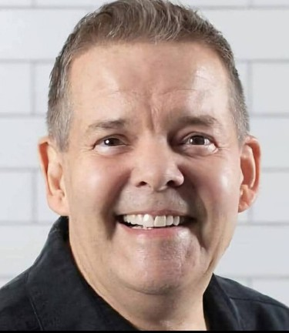If you listen to Hank Kuhlmann read the Omaha World Herald every Tuesday morning on RTBS, it won’t surprise you to learn that he has a background in broadcasting. His warm, gregarious voice has a way of putting listeners at ease,

even when he’s reading the grimmest of news.

Hank grew up in Sioux City, IA, where he attended Morningside College. There, he began doing booth announcing and station ID’s for the local TV station. Eventually, he moved to Omaha, where he worked at KESY and Light 96 radio, before transitioning to a long career with Omaha Steaks as a Training Specialist until his retirement in January of 2024.

Hank and his partner Don will never starve, as their freezer is full of discounted meat from Omaha Steaks. When Hank isn’t grilling dinner and hanging with Don and his cat, he loves to travel,

attend Broadway plays, edit photos, collect antiques, and watch old black-and-white movies.

IN MEMORY OF: JUDITH ‘JUDY’ PRICE

To learn more about Hank Kuhlmann, catch his interview with Ryan O, broadcast on Friday, April 18 at 5:45pm, repeated on Saturday, April 26 at 12:15pm. You can also listen on demand on our podcast page.

BY-RYAN OSENTOWSKI, PROGRAM DIRECTOR

BEKAH JERDE EXECUTIVE DIRECTOR

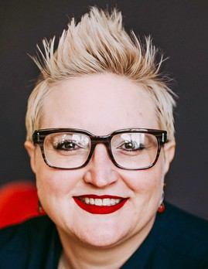

**DIRECTOR'S CORNER**

I am so grateful for the generous and celebratory response to our 50 Years of Service in 2024! A huge thank you to my incredible team – Cami, Michael, and Ryan – whose efforts led to a year of growth, connections, and astonishing results. Thank you to our dedicated volunteers, Board of Directors, and generous donors,

large and small, for an amazing 50th Year!

Audio Description is creating new connections in our

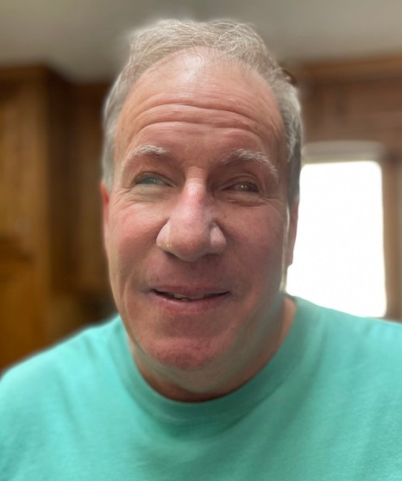community. In 2024, RTBS provided AD services for 62 individuals and ensured accessibility at 43 performances or events. RTBS began partnering with The Joslyn to incorporate audio description of art works in their collection. Looking forward, to ensure quality programming, RTBN will be improving our recording booths with added soundproofing and updated mixers in 2025. In the control room, we will be streamlining processes and implementing updated technology to improve the quality of the broadcast.

**A NOTE FROM THE CHAIRMAN**

RTBS had an amazing 2024. We proudly celebrated our 50th anniversary with tremendous style and flair. 2024 set a high bar for our organization. We accept that challenge and look forward to surpassing what we have done in the past.

As our population ages, the need for the essential services

BOB BURNS BOARD CHAIR

Radio Talking Book Service provides -- critical news, vital health information, delightful entertainment, and audio description of local arts events -- continues to grow.

As Board chair, I want to thank the volunteers whose generous donations of time and talent make our programming possible. I would also like to thank our listeners, the foundations and compassionate donors who selflessly support our mission, along with the individuals of our RTB family who together make it possible for us to continue to deliver the news and programs that our listeners rely on.

Finally, I would like to thank our incredible staff, Bekah, Ryan, Cami and Michael, who do an amazing job of maintaining a high standard of delivering our services to our listeners.

**DONATIONS: April 2024-March 2025**

### CO RPORATE/FOUNDATIONS

Anonymous

Alan & Marcia Baer Foundation Back 2 Health

Blue Barn Theater

Cari Sommer Charitable Fund Carson Group Holdings LLC Circle Theatre

Cox Charities

Dixon Family Foundation

Edward & Lida Robinson Charitable Trust Enterprise Holdings Foundation

Ethel S. Abbott Charitable Foundation Farm Credit Services of America James & Anne Foley Charitable Fund

Gilbert M. & Martha H. Hitchcock Foundation Ike & Roz Friedman Foundation

Immanuel Vision Foundation Jewish Community Center JK Barker Foundation

The Joslyn Kroger

Lincoln Financial Foundation Lozier Foundation

Manota E. Simon Foundation

Marshall & Mary Brondum Special Assistance Foundation Max & Victoria Dreyfus Foundation

Milton & Corinne Livingston Foundation McNamee-Simmons Foundation Mutual of Omaha Foundation

Omaha Community Playhouse Omaha Symphony

Omaha Venture Group Orpheum Theater

Retina Center of Nebraska, P.C. Robert Herman Storz Foundation Robin Hill Fund

Rupert Dunklau Foundation The Rose Theater

Sherwood Foundation Steinhart Foundation

University of Nebraska Foundation Webster Family Foundation William R. Patrick Foundation

### ORGANIZATIONS/COMMUNITY GROUPS

Aurora Lions Club Clay Center Lions Club

Columbus Noon Lions Club Cook Lions Club

### ORGANIZATIONS/COMMUNITY GROUPS

Crete Lions Club

Elmwood Tower Women's Association Gordon Lions Club

Imagine Inclusion

Kiwanis Club of Southwest Omaha Millard Lions Foundation

Murdock Lions Club Nebraska Lions Foundation Neligh Lions Club

Omaha Association of the Blind Omaha Westside Lions Club Outlook Nebraska

Papillion Area Lions Club Pierce Lions Club

Presbyterian Women in the Congregation Schuyler Class of 1969

Scottsbluff-Gering Lions Club

### WINING IN THE DARK 2024 SPONSORS

Anonymous

Golden Years Senior Relocation LLC Frontier Bank

Outlook Enrichment Bonnie Jerde Identity Marketing Omaha Magazine

Matt Jetter, Medicare Insurance Solutions Lori Hubbell, Better Homes & Gardens Loretta McNally, eXp Realty

### 50 YEARS OF SERVICE CELEBRATION SPONSORS

All of Us Together Avior Wealth

John & Elizabeth Fullerton Bonnie K. Jerde

Marco

National Federation of the Blind of Nebraska ONPXL

Outlook Nebraska

RDG Planning & Design

### INDIVIDUALS

Deb Ady

Sandy Alvarado Aubrey Akervik Melanie Anania Jon Anderson Nancy Anderson

### INDIVIDUALS

Anonymous Kelsey Arends Dean Arkfeld

& Peggy Reinecke Howard Bachman James & Susan Backer Zac Baer & Brian Bartels Kenneth Barjenbruch Melissa Barnett

Linda Basilico Bob Bastarache Belinda Beavers

Earl & Rose Berkey Al Bertacini

Amy Blanchard

Tom & Patrica Blasing Melodee Bock

Leslie Boesen

Joni & Bill Bollinger Bob Bosco

Mikell Bowsman Rich & Pat Brahmer Pat Brennan

Roger Brodersen Judy Brooks Andrea Brown

Bob & Samala Brown Buster Brown

John & Rosemary Brownrigg Greg & Sue Bruening

Mark Bulger Sue Burger Robert Burns

Chris Cady-Jones Michael & Cherie Carlson Rachel Carver

Christine Cary

Dr. John Chedester Jill Chleborad

Phyllis & Norman Choat Pamula Clifford

Tiffiny Clifton Nancy Coffman David Corbin Karen Cote Alistair Cullum Dolores Dawson

John & Carol Dennison Jodie DeSordi

Kay Dinkleman Nancy Dirks

Melinda & Juan Dominguez Marie Dougherty

### INDIVIDUALS

Mary Douglas Stephen Douglas Marina Drake

Lori Ecklebe & Tom Shomaker

Malia Emary Joe Ernst Megan Falke Ali Ferry

Lorene & Jim Fiala Mr. & Mrs. Rick Fickle Nancy Flearl

Sharon Flinn

Lawrence & Joan Friend Christina Frost

John & Elizabeth Fullerton Robert Fullerton

Scott & Tricia Fullerton Ellen Gaherty

Theresa Gerritzen John Glass

Sue & Cal Goding Polly Goecke Travis Grafe-Cline

Patrick & Jocelynn Gray Sherri Green

Mary Ann Griffin Donna Grimm Jeffery Grinnell Lynn Groff Haley Haas

Wendy Hamilton Michael & Britt Hanson Lee Harlan

Sally & Alan Harms Dick Harrington

John & Kathryn Hartman Elizabeth Harvey

Linda Hatfield Madi Havel Cheryl Hazel Monica Hickman Lakelyn Hogan Helen Hohndorf Lindsey Holley Nancy Holloran Heather Holmes Donna Houghton Tom Howe

David Huelsmann Kim Huff

Sharon Ishii-Jordan Bonnie K. Jerde

### INDIVIDUALS

Matt Jetter Ardith Johnson

Dean & Rhonda Josten Kim Jubenville Carlson Becca Kautz

Susan Kelley Marilee Kelly

Jim, Terri, & Nichole Kenagy Liz Kerrigan

John Kieran Susan Klaus Vickey Kleinsmith Tara Knapp

April Koske

Mary & John Krajicek Kerry & Elizabeth Krause Hank Kuhlmann

Nancy Kurtenbach David Laferla

Rebecca Armstrong Langle Lorene Larsen

Matthew Leaf Todd Lemke Deanne D. Leonard Ed Leslie

Kris Linder

Lori Livingston-Hubbell Barbara Loos

Victoria Lorenz James Lynch Victoria Macdonald Joyce Madsen Kenneth Mahaffey Sybil Mahan

Barry Malas

Yano & Cindy Mangiameli Randell Martin

Amy Mather

Bob & Terri Mathews Rhonda Matney

Erin McArthur

Marita McCarthy-Real Edward McCarty Julie McCarty

Tom McCaugherty Lynn McCormack Janet McCrae Catherine McGowan Lisa McIntosh Melissa McMullen Loretta McNally

Linda & Thomas A. Mertz Josie Metal-Corbin

### INDIVIDUALS

John Miller

Mark & Carolyn Miller Rick & Jane Miner Maria Miranda

Bert Mishler

Monica Mora-Handlos Anne Morgan

Ralph & Mikaelah Morocco

Megan Moslander Michael & Delores Murphy Paul & Peggy Murphy Kathy Mussack

Mark Nasser Barbara Naughtin RJ & Liz Neary Jane Nielsen

Joe Nittler Patrick Noonan Nancy Novotny

Margaret Nusser Gerlach

R.E. Nystrom David Offutt Gloria Olivo

Jane Onken-Roberts & Jim Roberts

Caitlin Osborn

Rich & Karen Osentowski Ryan Osentowski Dolores Ostrom

Dr. Stephen & Janet Papenfuss

Nicole Paul Nancy Pawloski

Tim & April Pearson Connie Pera Patricia Perry Karen Pesek

John Phillips Maya Pignatore Kristal Platt

Jon & Dorothy Polan Jean Prendergast Mike Prenger Leanne Prewitt Michelle Rankin

Bill Rasmussen Carol Ravnsborg

Cami & Shell Rawlings Shiela Rawlings Melissa Ray

Francie Rebolloso Daniel & Annie Rezac Mary Reznicek

Marty Riemenschneider

### INDIVIDUALS

Jo Roberts John Rogers Laura Romito

Earl & Rose Berkey Lauren & Philipp Ruhe Halsey & Reggie Ruhl Barbara Ruser

Carol Russell

Chris & Tami Saunders Amy Schindler

Patty Schmitz Lisa Schulze Kelle Scott

Larry & Judy Seger Linda Severin

Sue Sheeren John Shepherd Mike Sigmond Ruth Sillman Norma Skjold Steve Sleeper

Susan Slominski-Caster Melissa Whittle Smith MeMe Smith

Kyle Soares Gloria Sorensen James Springan Karen Stander John Stevens Sally Stich

Sharan Stoltenberg Rick Stone

Maureen & Matt Strain Chris & Barb Stratman Shilo & Eric Stueckrath Willa Jean Stutheit James Surber

David Sutherland Barbara Switzer Melissa Taylor Terry Theis

Mary & Jim Theisen Anita Theophilus Sheryl Thomas Kathryn Thomspon Linda Todd

Ralph & Charlotte Tosti Kaye Travnicek

Deb Trivitt

### INDIVIDUALS

Erin & Tyler Van Zee

Bart Vargas & Bekah Jerde Tom Vitamvas

Lois & Harris Voss Marialyce Walsh Anne Wattles Steve Wehrbein Sarah Wengert Jean Wheatcraft

Jason & Jennifer Whitney Laurel Wiegand

David Wiesman Sally Wilhelm Steven Willoughby Alfred Wise

Jenny Wulff

John & Sara Young Robert Zaback Sandra Zdan

### GIFTS IN HONOR OF

Ada & Mamie Patrecia Brodersen John Fullerton Michael Halula Bekah Jerde

Pat Jones Elijah Massey

Rhonda Matney Janet McCrae Ralph Morocco Dean Nielsen, Jr Ryan Osentowski Dr. Preema & Staff Diane Rappl

Cami Rawlings Mona Jean Roberts RTBS Volunteers

Kim at Weigel Williamson

### GIFTS IN MEMORY OF

Audrey Wright-Anderson & George Anderson

Dave Bandi Ann Boice John Bowsman

Jack & Sheila Brownrigg Dorothy Carter

### GIFTS IN MEMORY OF

Eloise Craft Josephine Curro Betty Dougherty Homer Douglas Lucille Dunlavy Anne Foley

Dr. Craig Fullerton Mike Gaherty Patrick Gray Helen Griffith

Ed & Janet Guthrie Steve Hahn

Myron Harris Mary Henney Gail Herbst Betty Hohndorf

Armond Insolman Pat Jones

Wayne Kaya Paul Kelly Elizabeth Kiewit James F. Krier Urdine Lancaster Elaine Joy Malas Elaine McCrae Glenn Miller Trudy Miller Willa Milone

Milford & Ethel Murphy Carl R. Ostrom

Andrea Otness

LaVon & Kay Peterson Bill Pfeiffer

Paul & Zorka Povich Judy Price

Michael & Morey Ramey Gwen Rasmussen Shiela Rawlings

Mary Reznicek Tom Sheeren Esther Simon

Dr. George K. Stoltenberg Richard Thomas

Robin Tosti Isabelle Trobough Alice Wagoner Tom Walsh

Ron Witt Mae Wittwer

*Radio Talking Book Service thanks everyone for their generous support!!*

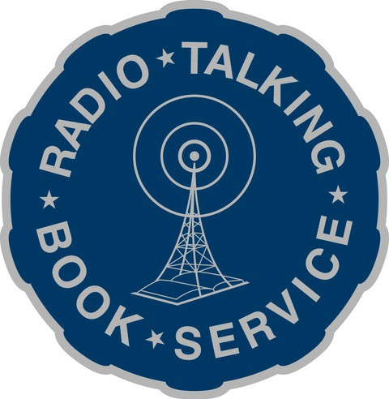

**RTBS Board Members R TBS Staff**

Robert Burns, President Michael Pflueger, Vice President Kyle Soares, Treasurer

Melissa Smith, Secretary Rachel Carver

Richard Harrington John Miller

Ralph Morocco Stephen Papenfuss, MD Francie Rebolloso

Bekah Jerde, Executive Director

Ryan Osentowski, Program Director

Cami Cavanaugh Rawlings Communications Director

Michael Halula, Board Operator