THE BROADCASTER

**R A D I O T A L K I N G B O O K S E R V I C E**

APRIL 2024 NEWSLETTER │ 2023 ANNUAL REPORT

**RTBS Celebrates**

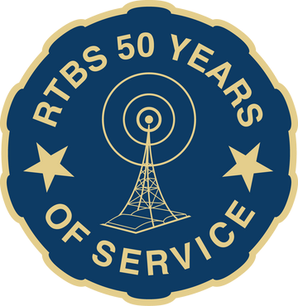**50 Years of Service in 2024!**

Radio Talking Book Service (RTBS) is celebrating 50 Years of Service in 2024! We are excited to continue serving our listeners with a mission to connect individuals who are blind, low vision, or print impaired to news, information, arts, and culture through the human voice and technology. Team RTBS will be celebrating this milestone all year long!

Founded in 1974 by Dr. Craig Fullerton, Radio Talking Book Network (RTBN) is Nebraska’s Audio Companion and only radio reading service. Over 80 volunteers read newspapers and magazines, and their diverse voices are broadcast across Nebraska and southwest Iowa over the radio and internet to 11,967 listeners. In 1992, we added Listening Link, an educational reading service, providing audio versions of textbooks and course material necessary for academic success. RTBS introduced our newest service, Audio Description (AD) in 2023. RTBS partners with community venues to provide live AD for theater performances, exhibits, parades, and more. Team RTBS has provided AD services for 54 individuals and ensured accessibility at 34 performances to date. Through human connection, RTBS enables all people to remain active and engaged in their community!

**Celebrate with us!**

**50th ANNIVERSARY CELEBRATION**

Save the Date! Join us on **September 18** at **Benson Theater** for an evening of celebration!

**$50K for 50 YEARS!**

We **need your help** to raise **$50,000** for our 50th Anniversary!

**Donate Today!**

**SPRING OPEN HOUSE**

Stop by the RTBS Studios on **May 16 from 4pm to 6pm** for a tour, snacks, & visit!

**GET YOUR TICKETS TODAY!!**

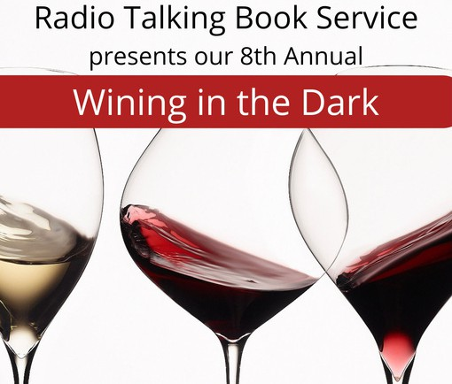

Radio Talking Book Service is excited to announce we will be holding our 8th Annual Wining in the Dark at Nosh Wine Lounge! Test your taste buds with wines from around the world in a blindfolded tasting and delight in delectable delicacies created for your pleasure by the chef at Nosh Wine Lounge.

WHEN:

Sunday, April 21

4 to 6 p.m.

WHERE:

Nosh Wine Lounge 1006 Dodge Street, Omaha

Get your tickets today!

There will be a raffle including a night at the Omaha Symphony, a Nebraska Bookshelf filled with signed copies, a Film Streams package, a golf outing, dinner at Block 16, and more!

Seating is limited. Please purchase tickets by April 19 at rtbs.org or call 402-572-3003 to RSVP. Tickets are $80/person including gratuity, raffle entry, and a donation to RTBS.

Sponsorship opportunities available; contact Cami at 402-572-3003.

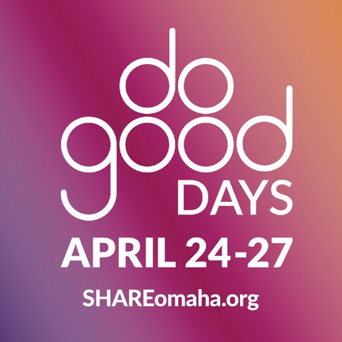**SAVE THE DATES!! DO GOOD DAYS ARE APRIL 24-27**

## Join in SHARE Do Good Days, April 24-27.

These 4 days are focused on all forms of support for local causes, and we can’t wait to see what the Omaha metro can do when we give together for more than one day!

Team RTBS is excited for our **Community Read- a-Book-a-thon** during Do Good Days! We are inviting folks to pop in to read a chapter (or two!) of a Nebraska authored book with a goal to finish recording the book in three days to broadcast on-air for our listeners!

## Do Good Days makes it easy to support us with your dollars – and more!

Visit shareomaha.org/nonprofit/radio- talking-book-service-inc to learn more!

**APRIL VOLUNTEER SPOTLIGHT:**

**VOLUNTEER SPOTLIGHTS**

M A R C H 2 0 2 4 :

B R O O K E W I L L I A M S

F E B R U A R Y 2 0 2 4 : J I M E L Y

J A N U A R Y 2 0 2 4 : M E M E S M I T H

D E C E M B E R 2 0 2 3 : D A V E L A F E R L A

N O V E M B E R 2 0 2 3 : K A Y E B E L L I N O

O C T O B E R 2 0 2 3 : T O M G A R V E Y

S E P T E M B E R 2 0 2 3 : R A C H E L S A M S O N

A U G U S T 2 0 2 3 :

B O B G O D I N G

J U L Y 2 0 2 3 :

K E N D R A K A R B O W S K I

J U N E 2 0 2 3 :

J E N N Y W U L F F

M A Y 2 0 2 3 :

T O M S H O M A K E R

**LARRY THORNTON**

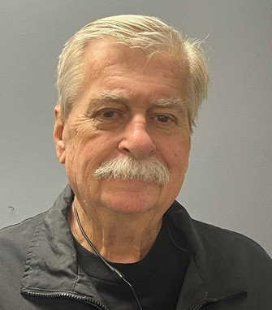Larry Thornton is the consummate volunteer at RTBS. He always approaches his reading with a cheerful demeanor. He is fun and respectful with his reading partners and almost never says no to a substitution request. Born and raised in South Omaha and Bellevue,

Larry graduated from Bellevue High in 1965. He was drafted into the Army and spent a year in Vietnam. When he came back, he worked at several jobs before discovering the joy of driving a truck and operating heavy machinery. Larry covered the whole gambit, working short day runs to long hall runs in a sleeper truck. He tried working for UPS at one point but disliked their high-pressure schedules.

Eventually, he moved to Council Bluffs, where he still lives with his wife, Sue. The only thing he loves as much as his wife are his cars (and motorcycle!), including his ‘56 ‘hot rod’ Chevrolet, his 2011 Camaro, his Corvette, and his Harley Davidson. Every summer, Larry and Sue participate in many car shows and often win trophies. Summer is the only time when Larry can’t always answer the call for a last-minute weekend sub read. He’s been with us at RTBS for six years and is going strong. Catch Larry every Monday morning at 10am reading the Lincoln Journal Star, as well as Tuesday mornings at 9:15am reading the Kearney Hub. Learn more about Larry in his interview with Ryan O, on our podcast page.

IN MEMORY OF:

LUCILLE DUNLAVY ANNE FOLEY MIKE GAHERTY SHERRYL RISSI WILLARD SPECH

BY-RYAN OSENTOWSKI, PROGRAM DIRECTOR

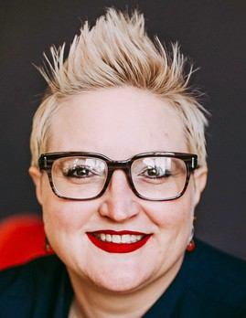

BEKAH JERDE EXECUTIVE DIRECTOR

# DIRECTOR'S CORNER

The past year was filled with new opportunities to serve a larger

audience, improve accessibility in community spaces, and create connections. Team RTBS introduced our first Spanish language programming, Mundo Latino, in 2023. Mundo Latino is a minority- owned publication and has been the voice of the Hispanic community in Nebraska since 1999. New in 2024, we added The Good News Show, a program filled with uplifting, encouraging news to provide a moment of relief in heavy news cycles. Team RTBS debuted our Meet the Author segment, a conversation between our volunteer readers and the Nebraska authors they read. Our new AD program is growing, expanding into more

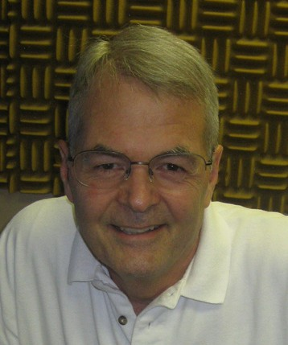theaters and beginning relationships with local art institutions. And, the best news...it’s our 50th Anniversary in 2024! What an incredible accomplishment fostered over the years by generations of dedicated volunteers, innovative staff members, supportive board members, and generous donors. Celebrate with us by attending an event, making a donation, volunteering, or telling a friend about RTBS. Stay tuned for the next 50 years!

# A NOTE FROM THE CHAIRMAN

Fifty years ago, Richard Nixon became the first U. S. president forced to resign after the Watergate Scandal. The 55-mile per hour national speed limit was approved to preserve gasoline in the country following the October 1973 oil embargo. The Sears Tower opened in Chicago as the world's tallest building. U. S. inflation reached 12.34 percent. And Radio Talking Book Service was born.

We have weathered many challenges since 1974, as a people, as a nation and as a radio station. And, as our population ages, the

RALPH MOROCCO

BOARD CHAIR

need for the essential services RTBS provides -- critical news, vital health information, delightful entertainment, and audio

description of local arts events -- continues to grow. These are challenging times. This year we'll choose our nation's leaders for the coming four years. We are confronting changing climate, working to avoid another world-wide recession, healing from the ravages of Covid-19, and coping with wars in the Middle East and in Europe. As a radio station, and as an audio description service, we continue to cope with the challenges of meeting the growing and changing needs of our listeners, and the annual dilemma of funding our services in the absence of federal or state support.

But we look forward to the years ahead. We are confident in the importance of our mission. We count on the generous gift of talent and time we receive from our committed volunteers, the enormous talent and skills of our dedicated staff, and the generous financial support of our listeners, and the foundations and compassionate donors who selflessly support our mission, allowing us to bring the printed word to life. Thank you for making it possible for Radio Talking Book to celebrate 50 years of service, and to prepare for 50 more!

**DONATIONS: April 2023-March 2024**

### CORPORATE/FOUNDATIONS

Anastasis Theater Blue Barn Theater

Cari Sommer Charitable Fund Dixon Family Foundation

Edward & Lida Robinson Charitable Trust Emspace + Lovgren

Enterprise Holdings Foundation

Ethel S. Abbott Charitable Foundation Farm Credit Services of America

Giger Foundation

The Hawks Foundation

Home Instead Senior Care Foundation Ike & Roz Friedman Foundation Immanuel Vision Foundation

JK Barker Foundation Kroger / Dillon Stores The Lozier Foundation

Manota E. Simon Foundation

Marshall & Mary Brondum Special Assistance Foundation Midlands Community Foundation

The Milton S. & Corinne N. Livingston Foundation Omaha Community Playhouse

Orpheum Theater Pettit's Bakery

Retina Center of Nebraska, P.C. Robert Herman Storz Foundation Robin Hill Fund

The Rose Theater

Rupert Dunklau Foundation Sherwood Foundation Steinhart Foundation Target Giving Circle Thrivent Financial

Webster Family Foundation William R. Patrick Foundation

### WINING IN THE DARK 2023 SPONSORS

Golden Years Senior Relocation LLC Frontier Bank

Outlook Enrichment Bonnie Jerde Identity Marketing Omaha Magazine EEP Solutions

CCA Homecare

Matt Jetter, Medicare Insurance Solutions EmSpace + Lovgren

Rahl Foundation

Lori Hubbell, Better Homes & Gardens Loretta McNally, eXp Realty

### ORGANIZATIONS/COMMUNITY GROUPS

Aurora Lions Club Clay Center Lions Club

Columbus Noon Lions Club Crete Lions Club

Dundee Garden Club Gordon Lions Club Murdock Lions Club Nebraska Lions Foundation Neligh Lions Club

Newman Grove Lions Club Ogallala Lions Club

Omaha Association of the Blind Omaha Westside Lions Club Outlook Nebraska, Inc

Papillion Area Lions Club Pierce Lions Club

Presbyterian Women in the Congregation Scottsbluff-Gering Lions Club

St James United Methodist Women Tekamah Lions Club

Wallace Lions Club

### UNDERWRITING

CCA Home Care Hillcrest Heath Systems Outlook Enrichment Senior Blue Book

### INDIVIDUALS

Deb Ady Melanie Anania

Rebecca Alvarado Anonymous

Kenneth Armstrong Family Melissa Barnett

Laura Beth Barr Brian Bartels Bob Bastarache Jana Benitez Sandra Bianchi

Tom & Patrica Blasing Ann Boice Family

Ray Boice

Joni & Bill Bollinger Mikell Bowsman

Jimmy Brasch & Helen Ott- Brasch

Pat Brennan Roger Brodersen

Judy Brooks

### INDIVIDUALS

Bob & Samala Brown

John & Rosemary Brownrigg Greg & Sue Bruening Stephen Bunting

Christian Burk Gerald Bushnell Sue Burger

Ken & Irene Burson Nick & Evelyn Calava Jim Carlson

Elaine Chapin John Chedester

Phyllis & Norman Choat Michelle Christenson Gregory & Julie Classen Imogene Clements Pamula Clifford

Nancy Coffman Christopher Cold Mary Contreras Laura Cooper Karen Cote Alistair Cullum Linda & Alan Dane Jean Davis

Pamela & Donald Dennis Carol Dennison

John & Joan Denny Tami Doll

Melinda Dominguez Marie Dougherty Stephen Douglas Dolores Doyle Marina Drake

Kenneth & Susan Drood Lucille Dunlavy

Lori Ecklebe Malia Emary Joe Ernst

Bill & Eva Everhart Victoria Fanta Amy & Todd Feltz Lorene & Jim Fiala Sarah & Mike Fratt

Lawrence & Joan Friend Christina Frost

Bob & Nan Fullerton John & Betty Fullerton Scott & Tricia Fullerton Peter Gadzinski

Pat Geary Carol Gibilisco Sue Goding

### INDIVIDUALS

Polly Goecke Christian Gray

Patrick & Jocelynn Gray Sherri Green

Donna Grimm Jeffery Grinnell

Michael & Shirley Gude Haley Haas

Wendy Hamilton Terry & Judy Haney

Michael & Britt Hanson Dick Harrington

Jim & Diana Harrison John & Kathryn Hartman Linda Hatfield

Cheryl Hazel Brenda Hennigs Lakelyn Hogan Paul Hogan Mary Hogan Helen Hohndorf Lindsey Holley Heather Holmes

Elizabeth Hoover Donna Houghton David Huelsmann Shirley Humphrey Jean Hundtoft Bekah Jerde Bonnie K. Jerde Diane Johnson Margaret Johnston

Kim Jubenville Carlson Evelyn Evy Katz

Nancy Katz Rebecca Kautz

Anne & Albert Kearney Patrick and Susan Keefe Susan Kelley

Liz Kerrigan John Kieran

Milton and Marsha Kleinberg

Vickey Kleinsmith Tara Knapp

Maria Knudtson Cynthia Konsor Lauren Kotulak Bartels John & Mary Krajicek Marj Krawczyk

Jack and Marie Kubat Barbara Kuhn

David Laferla

### INDIVIDUALS

Lorene Larsen Wendy Leitch Robert & Carla Leuck Lenora Levin

Joyce Madsen Joyce Magee

Yano & Cindy Mangiameli Jack Martin

Randell Martin Amy Mather

Bob & Terri Mathews Zach Mays Annastacia McCarty Edward McCarty Tom McCaugherty Lynn McCormack Janet McCrae Catherine McGowan Lisa McIntosh

Bob and Kay McMeen Melissa McMullen Loretta McNally

Linda & Thomas A. Mertz Camille Metoyer Moten John Miller

Mark & Carolyn Miller Sandra & James Miller Rick Miner

Steve Minor Maria Miranda Stephanie Miske Anne Morgan Ralph Morocco

Jo and Steve Morton Sue Mouttet

Paul Murphy Lindsay Muse Kathy Mussack Mark Nasser Kasie Natzel Barbara Naughtin Jane Nielsen Patrick Noonan

R.E. Nystrom Kathy Onken

Jane Onken-Roberts & Jim Roberts

Rich & Karen Osentowski Ryan Osentowski Dolores Ostrom

Nancy Pawloski

Peggy & Edward Pease Connie Pera

### INDIVIDUALS

Patricia Perry Larry Peterson John Phillips Kristal Platt

Jon and Dorothy Polan Jean Prendergast

Mike Prenger Connie Randazzo Michelle Rankin Carol Ravnsborg

Cami & Shell Rawlings Shiela Rawlings Melissa Ray

Francie Rebolloso Daniel & Annie Rezac Jo Roberts

John Rogers Laura Romito

Kenneth & Susan Rood John & Gail Rosso Arthur & Dorothy Sahlstein

Chris & Tami Saunders Amy Schindler

Kelle Scott Jeanine Seamans Larry & Judy Seger Erich Sender Linda Severin

Sue Sheeren John Shepherd

Paul & MaryLou Sherrerd Tom Shomaker

Curt Siemers Michael Sigmond David & Mary Skiles

Susan Slominski-Caster Melissa Smith

Gloria Sorensen Karen Stander John Stevens Rick Stone

Maureen & Matt Strain Chris & Barb Stratman Willa Jean Stutheit Deborah Surber

David Sutherland Jeanne Swartz Barbara Switzer Anita Theophilus

### INDIVIDUALS

Sheryl Thomas Catherine L Tierney Linda Todd

Ralph Tosti Kaye Travnicek

Don Van Moorleghem Erin Van Zee

Bart Vargas Terry Veylupek

Tom & Bev Vitamvas Lois & Harris Voss Marialyce Walsh Sarah Watson

Anne Wattles Steve Wehrbein Jean Wheatcraft David Wiesman Sally Wilhelm Brooke Williams Steven Willoughby Alfred Wise

Fran Witt Jenny Wulff

John & Sara Young

### GIFTS IN HONOR OF

Aunt Dorothy Jimmy Brasch Patrecia Brodersen Susan Burger Scott Erikson Family & Friends

Laura & Bruce Hadwiger Michael Halula

Shirley Humphrey Bekah Jerde

Ed Leslie Janet McCrae Betty Minor Don Nagel

Ryan Osentowski Cami Rawlings Mona Jean Roberts RTBS Staff

RTBS Volunteers Rev. M. Walsh, SJ

### GIFTS IN MEMORY OF

Ada & Mame Aunt Dorothy

Audrey Wright Anderson & George C. Anderson

Gloria & Kenneth Armstrong Dave Bandi

Ednamae Beaty Robert Bianchi Carole Ann Boice John C. Bowsman Jr.

Jack & Sheila Brownrigg Frank Calava

Dorothy Carter Jefford & Pat Cold Josephine Curro Betty Dougherty Lucille Dunlavy Bernice Falk Craig Fullerton Jim Fullerton

Thomas Michael ‘Mike’ Gaherty Betty Hohndorf

Mark Johnson Mickey Johnston Elizabeth Kiewit James F. Krier Elaine McCrae Trudy Miller Debbie Misenhelter Milford Murphy Myron J. Nelson Andrea Otness

Alice Finley Sullivan Perry Alice Jane Peterson LaVon & Kay Peterson

Bill Pfeiffer Willard Spech Richard Thomas Robin Tosti Isabelle Trobough Alice Wagoner Tom Walsh Glendora Weiland Georgia Wheeler Ron Witt

Mae Wittwer Lois Wood Dick Zlab

*Radio Talking Book Service thanks everyone for their generous support!!*

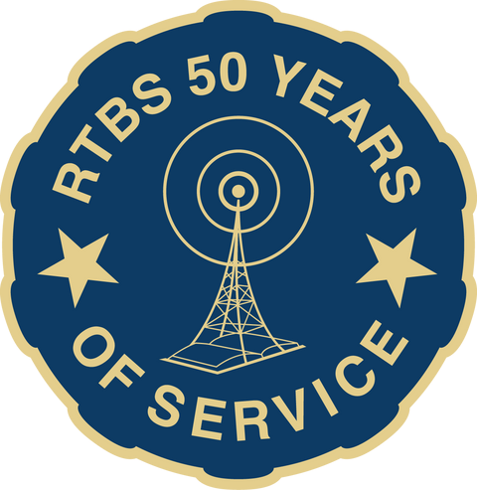

**RTBS Board Members RTBS Staff**

Ralph Morocco, President Michael Pflueger, Vice President Kyle Soares, Treasurer

Richard Harrington, Secretary Robert Burns

Rachel Carver Christopher Connor, OD John Miller

Stephen Papenfuss, MD Melissa Smith

Bekah Jerde, Executive Director

Ryan Osentowski, Program Director

Cami Cavanaugh Rawlings Communications Director

Michael Halula, Board Operator